Analytics for Competitive Advantage: Measuring Productivity Improvements from Generative AI
Course No.: XXXXXXXX
Project Report
BITS ID: XXXXXXXX
Program: MBA Business Analytics
Project Area: Analytics for Competitive Advantage

Dissertation / Project Work carried out at:

Leading IT Services Company, New Delhi

Work Integrated Learning Programmes Division (WILPD),
BIRLA INSTITUTE OF TECHNOLOGY & SCIENCE, PILANI,
VIDYA VIHAR, PILANI, RAJASTHAN
(May 2026)

ACKNOWLEDGEMENTS

I would like to express my sincere gratitude to all those who have supported and guided me in the successful completion of this project.

First and foremost, I would like to thank the Head of the Organization for providing me with the opportunity to undertake this project and for creating a professional environment that encouraged learning and development.

I am deeply thankful to my Supervisor [Name Redacted], and Additional Examiner, [Name Redacted], for their constant guidance, valuable suggestions, and continuous support throughout the project. Their practical insights and encouragement significantly contributed to the successful completion of this work.

My heartfelt thanks go to my Project Faculty Mentor and Guide, [Name Redacted] Sir, for his continuous motivation, academic guidance, and valuable support throughout the project duration. His mentorship played a vital role in completing this report successfully.

I would also like to sincerely thank all the faculty members of every semester whose teaching, guidance, and encouragement helped me enhance my knowledge, develop a better understanding of the subject, and successfully complete my MBA program and this project.

Finally, I would like to thank all other individuals, both within and outside the organization, who directly or indirectly assisted me during this project. Their cooperation, encouragement, and support are sincerely appreciated.
BIRLA INSTITUTE OF TECHNOLOGY & SCIENCE, PILANI
Work Integrated Learning Programmes Division (WILPD)

PROJECT ABSTRACT

Student Id | XXXXXXXXXX
Programme Name | Dissertation/Project Final Report
Semester | Final semester
Project Title | Leveraging Business Analytics for Competitive Advantage: The Impact of Generative AI on Employee Productivity
Organization Supervisor Name & Designation | [Name Redacted], Product Owner
Additional Examiner Name & Designation | [Name Redacted], Business Analyst
Faculty Mentor Name & Designation | [Name Redacted], Lead Instructor and Mentor
Submission Date | May/2026

Abstract:
The rapid adoption of Generative Artificial Intelligence (AI) in the IT services industry has created significant opportunities to improve employee productivity, enhance work quality, and accelerate task execution. Organizations are increasingly integrating AI tools such as ChatGPT, GitHub Copilot, Microsoft Copilot, and Gemini into knowledge-intensive functions including software development, documentation, testing, analytics, and reporting. Despite growing implementation, many organizations face challenges in systematically measuring and quantifying the actual productivity gains achieved through these technologies.
This study aims to evaluate the impact of Generative AI on employee productivity and examine how such improvements contribute to competitive advantage. The research adopts a quantitative approach using primary data collected through a structured survey of working professionals, primarily from the IT services sector. The study focuses on comparing AI-assisted workflows with traditional non-AI methods across key productivity dimensions such as task completion time, work efficiency, reduction in manual effort, output quality, and decision-making support.
Business analytics techniques such as descriptive analysis, comparative analysis, correlation, and regression are proposed to interpret the data and identify meaningful relationships between AI adoption and performance outcomes. In addition, a composite productivity index may be developed to assess overall gains resulting from AI usage.
The expected findings of the study are likely to indicate that Generative AI significantly enhances employee productivity by reducing turnaround time, improving accuracy, increasing efficiency, and enabling faster project delivery. The study also seeks to establish that AI-driven productivity improvements can support competitive advantage through improved service quality, cost efficiency, and better resource utilization.
This research contributes both academically and practically by providing a structured framework for measuring AI-enabled productivity and supporting organizations in making data-driven decisions regarding future AI adoption strategies.

Project Areas:
Project Area: Analytics for Competitive Advantage
This project falls under the broad domain of Analytics for Competitive Advantage and focuses on understanding how Generative AI can be leveraged as a strategic productivity enabler within the IT services industry.
The increasing adoption of Generative AI in the IT services industry has created significant opportunities for improving employee productivity. However, organizations face challenges in systematically measuring and quantifying these improvements. While AI tools are widely used to automate repetitive work, accelerate task completion, generate content, assist coding, and improve decision-making, many companies still lack a structured framework to evaluate the real business impact of these technologies.
The study therefore examines how business analytics techniques can be used to measure productivity gains resulting from AI adoption. It investigates important parameters such as time savings, efficiency improvement, output quality enhancement, reduction in rework, faster delivery timelines, and overall organizational effectiveness.
The project also explores the strategic linkage between productivity improvement and competitive advantage. Organizations that effectively utilize Generative AI may gain advantages through faster service delivery, better quality outputs, optimized costs, improved employee efficiency, and enhanced responsiveness to market demands.
As a general study / white paper, the project provides analytical insights, measurement models, and practical recommendations for organizations seeking to maximize returns from Generative AI adoption while building long-term competitive capability.

Key Words:
Generative AI, Employee Productivity, Business Analytics, Competitive Advantage, IT Services Industry, Artificial Intelligence, Productivity Measurement, Workflow Efficiency, Output Quality, Time Savings, Automation, AI Adoption, Data-Driven Decision Making, Organizational Performance, Digital Transformation
Table of Content
ACKNOWLEDGEMENTS 2
Abstract: 3
Project Areas: 4
Key Words: 4
CHAPTER 1: INTRODUCTION 8
1.1 Background of the Study 8
1.2 Requirement Statement / Problem Statement 8
1.3 Project Objectives 9
1.4 Project Scope 10
1.5 Methodology 11
1.6 Plan of Work 12
CHAPTER 2: LITERATURE REVIEW 12
2.1 Introduction to Work Completed after Mid term 12
2.2 Literature Study 13
2.2.1 Introduction 13
2.2.2 Evolution of Generative AI and Productivity Theory 14
2.2.3 Generative AI and Productivity Enhancement 16
2.2.4 Measuring Productivity in AI-Driven Environments 17
2.2.5 Generative AI and Competitive Advantage 18
Chapter 3: Research Methodology 20
3.1 Research Gaps Identified 20
3.2 Relevance of the Current Study 20
3.3 Development of Research Framework 21
3.4 Design of Survey Instrument 22
3.5 Initiation of Data Collection 26
3.6 Resource Requirement 27
Chapter 4: Data Analysis & Interpretation 29
4.1 Introduction 29
4.2 Data Preparation and Exploratory Analysis 30
4.3 Descriptive Statistics 33
4.3.1 Individual-Level Analysis 33
4.3.2 Project-Level Regression Analysis 38
4.3.3 ROI and Financial Impact 41
4.4 Dashboard Details and Data Source 43
Chapter 5: Conclusion 46
5.1 Recommendations and Future Scope 46
5.2 Closing Statement 47
5.3 Future Research Directions 47
6. Risks and Mitigation Plan 47
7. Expected Benefits 48
8. Annexures 49
Annexure A: Survey Questionnaires 49
Annexure B: Survey Responses 54
Annexure C: Python Code Screen shots 55
Annexure C: Link to Files 56
9. Glossary 56
10. References 57
11. Summary of how the feedback for Project Midterm have been addressed 58

Table for Figure
Figure 1. Evolution of AI to Generative AI 14
Figure 2. Adoption of Generative AI among respondents 31
Figure 3. Average time saved due to AI usage 31
Figure 4. Frequency of Generative AI usage 32
Figure 5. Average Task Completion Time Before vs. After AI 36
Figure 6. AI Frequency vs. Productivity Gain by Industry 36
Figure 7. AI Productivity Index Distribution Across Industries 37
Figure 7. Regression coefficients across project-level outcomes. 38
Figure 8. Factor loadings for project-level outcomes. 39
Figure 9. AI usage versus project-level outcomes (categorical) 40
Figure 10. AI Adoption Executive‑Level Dashboard 43
Figure 11. AI Adoption Executive‑Level Dashboard 44
Figure 12. Role-Wise Response Dashboard 44
Figure 13: Productivity Index calculator. 54
Figure 14: Test Performed 54
Figure 15: Regression Result 55

CHAPTER 1: INTRODUCTION

Background of the Study
Artificial Intelligence (AI) has emerged as a transformative technology, reshaping business operations across industries. In the IT services sector, AI is increasingly being leveraged to enhance efficiency, automate repetitive tasks, and enable data-driven decision-making. Organizations are adopting AI to improve service delivery, reduce operational costs, and gain a competitive advantage.
The IT services industry relies heavily on knowledge-based work, including software development, testing, documentation, and data analysis. Traditionally, these tasks required significant manual effort and time. However, with the advancement of AI technologies, especially Generative AI, there has been a shift in how these tasks are performed.
Generative AI has introduced new capabilities by enabling systems to generate content such as text, code, and insights. This has significantly improved the productivity of employees by reducing manual effort and enhancing output quality. Organizations are increasingly integrating AI tools into their workflows to improve efficiency and performance.
Industry studies suggest that AI adoption is rapidly increasing, with a significant proportion of tasks in knowledge-intensive roles being partially automated. This highlights the importance of evaluating the impact of AI on employee productivity using structured and analytical approaches.

Requirement Statement / Problem Statement
The increasing adoption of Generative AI in the IT services industry has created significant opportunities for improving employee productivity. However, organizations face challenges in systematically measuring and quantifying these improvements.
Most existing assessments of AI impact are based on subjective perceptions rather than objective data. While employees may report increased efficiency and reduced effort, there is limited empirical evidence to validate these claims. Additionally, organizations lack standardized frameworks to compare productivity between AI-assisted and traditional workflows.
For example, companies like Tata Consultancy Services and Accenture are actively integrating AI tools into their operations to enhance efficiency and service delivery. However, evaluating the actual impact of these tools on employee productivity remains a complex challenge due to the absence of structured measurement models.
Another key challenge lies in linking productivity improvements to broader organizational outcomes such as competitive advantage. While it is widely acknowledged that AI can improve efficiency, there is limited research that establishes a direct and measurable relationship between AI-driven productivity gains and strategic benefits.
Furthermore, productivity improvements are multidimensional, involving factors such as time efficiency, work efficiency, and output quality. Traditional metrics fail to capture this complexity, leading to incomplete assessments.
These challenges highlight the need for a data-driven approach that can:
- Quantify productivity improvements resulting from AI adoption
- Compare AI-assisted and non-AI workflows
- Establish a measurable relationship between AI usage and performance outcomes
- Link productivity gains to competitive advantage
This study aims to address these challenges by developing a structured analytical framework to evaluate the impact of Generative AI on employee productivity.
Recent industry research by Deloitte (2024) emphasizes that the impact of Generative AI is felt first at the task level, where routine and knowledge-intensive activities are disrupted, before aggregating into broader job and organizational transformations. This “task-first, job-later” framing underscores the importance of measuring micro-level productivity improvements and then testing how these gains scale into project-level and organizational outcomes.
This study therefore positions its research question not only to validate individual productivity gains but also to empirically examine the pathways through which micro-level efficiencies aggregate into macro-level competitive advantage.

Project Objectives
The primary objective of this study is to evaluate how Generative AI influences employee productivity and how these improvements contribute to achieving a competitive advantage using business analytics techniques.

Specific Objectives

- To measure and quantify productivity improvement by analysing changes in task completion time, efficiency, and output quality before and after the adoption of Generative AI.
- To compare performance outcomes between AI-assisted and traditional (non-AI) workflows using quantitative analysis of survey data.
- To examine the relationship between AI usage intensity and productivity levels by applying statistical techniques such as correlation and regression analysis.
- To develop a productivity index by combining key performance indicators (e.g., time savings, efficiency, and quality improvement) to assess overall productivity gains.
- To evaluate the contribution of AI-driven productivity improvements to competitive advantage, in terms of faster delivery, improved work quality, and enhanced decision-making capabilities.

To strengthen this analysis, Bain & Company’s industry benchmarks on automation potential (30–50% of labor time in professional and IT services) are used as external reference points to justify scenario analysis and to contextualize the productivity gains observed in this study.

Project Scope
This study is limited to the IT services sector, with a primary focus on different job roles in IT services. For comparison and better understanding, one other leading IT services company may be considered. The analysis is based entirely on primary data, ensuring reliability and ease of access.
The project focuses on understanding how business analytics techniques can be applied to:
- Evaluate productivity and efficiency improvements from AI usage
- Analyse variability in returns linked to productivity improvements
- Support data-driven managerial and strategic decision-making
Scope of the Study:

- Industry: IT & Consulting Services
- Data Type: Primary data
- Data Sources: Survey of IT professionals
- Focus: Productivity comparison between AI-assisted work and traditional non-AI methods
In-Scope:

- Productivity metrics such as:
  - Task completion time
  - Efficiency improvement
  - Output quality perception
- Comparative analysis:
  - AI-assisted vs non-AI workflows
- Survey-based primary data analysis
- Comparative analytics to evaluate how productivity improvements support competitive advantage
- Statistical analysis (descriptive, comparative, regression)
Out-of-Scope:

- Confidential organisational or internal operational data
- Technical evaluation or development of AI models
- Client-specific or confidential financial information
- Detailed project-level or operational implementation analysis
Data Scope and Boundaries:

- Primary Data: Survey responses from IT professionals
- Secondary Data: Industry reports on AI adoption (for context only)
- Industry: IT Services and Consulting
- Geography: Primarily IT professionals, as well as other working professionals.
Limitations:

While the study aims to provide meaningful insights, certain limitations must be acknowledged:
- Dependence on self-reported survey data, which may introduce bias
- Limited sample size, affecting generalizability of results
- Lack of access to confidential organizational performance data
- Time constraints in data collection and analysis
- Variability in respondents’ understanding and usage of AI tools

Significance of the Study:

This study is significant from both academic and practical perspectives. It contributes to the existing body of knowledge by addressing gaps related to the measurement of AI-driven productivity improvements.
From a practical standpoint, the study provides insights that can help organizations make informed decisions regarding AI adoption and implementation. By establishing a data-driven framework, it enables organizations to evaluate the effectiveness of AI tools and optimize their usage for maximum benefit.
Industry reports from organizations such as McKinsey & Company suggest that Generative AI has the potential to significantly enhance productivity across various functions. This study builds on such insights by providing empirical validation and structured analysis.

Methodology
This study adopts a quantitative research approach supported by business analytics techniques to evaluate the impact of Generative AI on productivity.
Data Sources
- Primary Data: The study is primarily based on primary data collected through survey responses, supported by secondary data from industry reports and academic literature.
Analytical Techniques
- Descriptive Analytics: To summarise productivity metrics and identify patterns
- Comparative Analysis: To compare productivity between AI-assisted and non-AI work methods
- Productivity Index Calculation: To create a composite measure of efficiency gains. Composite score based on:
  - Time savings
  - Efficiency improvement
  - Quality enhancement

Plan of Work
- Project topic finalization.
- Design and validate survey questionnaire.
- Collect responses from IT professionals.
- Clean and structure the dataset.
- Perform comparative productivity analysis.
- Estimate impact using analytical models.
- Interpret findings in relation to competitive advantage.
- Preparation of findings, conclusions, and recommendations
Milestone | Planned Timeline | Status | % Completion
Project Topic Finalization | Week 1- 2 | Completed | 100%
Literature Review | Week 3-4 | In Progress | 100%
Design and validate survey questionnaire | Week 3–4 | Completed | 100%
Survey Distribution | Week 5–6 | In Progress | 100%
Data Collection | Week 5–7 | In Progress | 100%
Data Cleaning & Preparation | Week 7–8 | Yet to Start | 100%
Data Analysis | Week 8–10 | Yet to Start | 100%
Final Report Preparation | Week 10–12 | Yet to Start | 100%

CHAPTER 2: LITERATURE REVIEW

Introduction to Work Completed after Mid term
The primary objective of this project is to evaluate the impact of Generative Artificial Intelligence (AI) on employee productivity and examine its role in enabling competitive advantage within the IT services industry. With the increasing adoption of AI tools across knowledge-intensive functions, this study aims to provide a structured and data-driven assessment of their influence on efficiency, output quality, and organizational performance.
At the mid-semester stage, the project has progressed through key phases of the research lifecycle, including literature review, research framework development, survey design, and initiation of data collection. These activities have ensured alignment with the research objectives and established a strong methodological foundation.
An extensive literature review has been conducted to understand existing perspectives on AI-driven productivity and competitive advantage. This review has identified key themes such as efficiency gains, quality improvements, and automation benefits, while also highlighting the absence of standardized frameworks for measuring productivity impacts.
Based on these insights, a conceptual research framework has been developed to examine the relationship between AI usage, productivity outcomes, and competitive advantage. This framework provides a clear analytical structure for the study and supports empirical validation.
A structured survey instrument has been designed as the primary data collection tool, capturing key dimensions such as AI usage patterns, productivity metrics, output quality, and business impact. The questionnaire has been refined to ensure clarity and relevance.
Data collection has been initiated through professional networks, with initial responses received. Efforts are ongoing to increase the sample size to improve the reliability of findings.
An analytical approach has also been defined, incorporating techniques such as descriptive analysis, comparative analysis, and regression modelling to evaluate the relationship between AI usage and productivity.
Preliminary observations suggest increased adoption of AI tools, along with improvements in task completion time, efficiency, and output quality. While these findings require further validation, they align with trends identified in the literature.
Overall, the work completed thus far provides a solid foundation for subsequent stages of data analysis and interpretation, enabling the study to generate meaningful insights on the role of Generative AI in enhancing productivity and competitive advantage.

Literature Study

2.2.1 Introduction
A comprehensive review of academic literature, industry reports, and research publications has been conducted to examine the role of Generative Artificial Intelligence (AI) in enhancing workforce productivity, particularly within the IT services industry. The review focuses on identifying key trends, analytical approaches, and existing gaps in measuring AI-driven productivity improvements.
The literature indicates a rapid and widespread adoption of Generative AI tools across organisations, particularly in software development, documentation, data analysis, and testing. Existing studies consistently highlight improvements in efficiency, reduction in task completion time, and enhancement in output quality as key outcomes of AI-assisted workflows. However, despite these advancements, there remains a lack of standardised and quantitative frameworks to systematically measure productivity improvements. Moreover, empirical evidence establishing a direct and measurable linkage between AI-driven productivity gains and competitive advantage is still limited.
The key insights derived from the literature can be summarized as follows:
- Increasing adoption of Generative AI across IT services functions
- Significant improvements in efficiency, turnaround time, and output quality
- Absence of standardized and quantitative productivity measurement frameworks
- Limited empirical validation linking productivity improvements to competitive advantage
These findings highlight a clear research gap and emphasize the need for a structured, data-driven approach to evaluate productivity improvements and their strategic implications. This gap forms the foundation and motivation for the present study.

2.2.2 Evolution of Generative AI and Productivity Theory
Evolution of Generative AI
The development of Generative AI represents a significant milestone in the evolution of artificial intelligence. Early AI systems were primarily rule-based, relying on predefined logic to perform specific tasks. These systems could not learn from data or adapt to new scenarios.
With the advancement of machine learning, AI systems gained the ability to identify patterns in data and make predictions. However, their capabilities were still limited to analytical and predictive tasks. The introduction of deep learning and neural networks marked a breakthrough, enabling machines to process large volumes of data and perform complex computations.
A transformative shift occurred with the development of transformer-based models, which significantly improved the ability of AI systems to understand context and generate coherent outputs. This led to the emergence of Large Language Models (LLMs), which form the foundation of modern Generative AI tools.
Productivity Theory
Productivity in the digital age has long been debated through the lens of Solow’s Productivity Paradox, which suggested that investments in information technology did not immediately reflect in productivity statistics.
In the current landscape, research suggests that GenAI may finally resolve this paradox. Unlike previous technology cycles (like the ERP or Cloud transitions), GenAI has a "low-barrier to entry" through natural language interfaces, allowing for a much faster "time-to-value." This section explores the shift from measuring productivity as "output per hour" to "value-added per task."
Theoretical Framework: The Resource-Based View (RBV)
To understand how GenAI creates a competitive advantage, this study adopts the Resource-Based View (RBV). According to RBV, a firm achieves a sustainable advantage when it possesses resources like:
- Valuable: Reducing costs or increasing client value.
- Rare: Not possessed by many competitors.
- Inimitable: Hard for others to copy.
- Non-substitutable: Cannot be replaced by other common tools.
Tools such as ChatGPT, GitHub Copilot, and Google Gemini have demonstrated the practical applications of Generative AI in real-world scenarios. These tools enable users to generate content, write code, analyse data, and automate workflows with minimal manual effort.
The evolution of Generative AI has shifted its role from a supportive tool to a strategic enabler of productivity and innovation. Organizations are now integrating these tools into their core operations to enhance efficiency and gain a competitive edge. According to industry reports, Generative AI has the potential to automate a substantial portion of tasks in sectors such as IT services, consulting, and finance. A key limitation in existing research is the absence of integrated measurement frameworks. Most studies analyze productivity dimensions in isolation rather than combining them into a unified index.
This creates a gap in understanding the overall impact of AI on productivity, reinforcing the need for a composite productivity index that integrates multiple performance indicators.

Figure 1. Evolution of AI to Generative AI
Deloitte (2024) highlights that Generative AI initially disrupts tasks rather than entire jobs. Routine and knowledge-intensive activities are automated first, while organizational redesign and reskilling follow later. This perspective supports the need to measure micro-level productivity gains before assessing macro-level competitive advantage.

2.2.3 Generative AI and Productivity Enhancement
Recent research highlights that Generative Artificial Intelligence (AI) has significant potential to enhance productivity, particularly in knowledge-intensive and cognitive tasks. Studies by Erik Brynjolfsson, along with co-authors, demonstrate that AI-assisted workers are able to perform tasks more efficiently by reducing the time required to complete routine and repetitive activities. Similarly, Shakked Noy and Whitney Zhang found that individuals using Generative AI tools completed writing tasks faster while also achieving improvements in output quality. A critical theme in recent literature (e.g., Dell’Acqua et al., 2023) is the concept of the Jagged Frontier. Research shows that AI significantly boosts productivity for tasks within its capabilities (like writing boilerplate code or summarizing documents). However, for tasks outside this frontier (complex logical reasoning or highly creative architecture), over-reliance on AI can lead to "hallucinations" and a decrease in quality.
These findings suggest that Generative AI enhances productivity through multiple mechanisms. Primarily, AI reduces the time required for task completion by automating repetitive processes and providing instant outputs. Additionally, it improves the quality of deliverables by minimizing human errors and enhancing accuracy. AI also contributes to efficiency gains by enabling employees to focus on higher-value tasks rather than routine operations.
Key productivity improvements observed in the literature include:
- Reduction in task completion time
- Improvement in output quality and accuracy
- Enhanced efficiency in repetitive and structured tasks
- Increased consistency in task execution.
Further research by Fabrizio Dell’Acqua indicates that AI tools enable employees to perform tasks with greater consistency and reliability, particularly in complex problem-solving scenarios. However, the study also emphasizes that productivity gains are not uniform and depend on factors such as user expertise, familiarity with AI tools, and the nature of tasks being performed.
Industry insights from McKinsey & Company (2023) further reinforce these findings, suggesting that Generative AI has the potential to significantly enhance productivity across various functions, including software development, customer operations, and content creation. Time savings and improved output quality are identified as the primary drivers of these productivity gains.
Bain & Company (2025) estimates that Generative AI can automate between 30% and 50% of labor time in knowledge-intensive industries such as IT services, finance, and professional services. Administrative functions show the highest potential (~50%), while IT and analytics roles align with ~38–40%. These benchmarks provide external validation and scaling parameters for the productivity gains observed in this study.
AI Adoption in the IT Services Industry

The IT services industry has emerged as a leading adopter of Generative AI technologies, driven by the need to improve operational efficiency, reduce costs, and enhance service delivery. Organizations are increasingly integrating AI tools into their workflows to automate tasks and improve overall productivity.
According to reports by McKinsey & Company (2023), Generative AI has the potential to automate a significant proportion of tasks in knowledge-based roles, thereby transforming the nature of work. Similarly, Accenture (2023) highlights that AI-driven automation is fundamentally reshaping traditional workflows by reducing manual intervention and enabling faster execution of tasks.
AI adoption within IT services is particularly prominent in the following functional areas:
- Software development and code generation
- Documentation and report preparation
- Testing, debugging, and quality assurance
- Data analysis and insights generation
These applications demonstrate how AI is being embedded across the value chain to improve both efficiency and output quality. However, despite the widespread adoption, organizations face significant challenges in evaluating the tangible benefits of AI. Reports from Gartner (2023) indicate that the absence of standardized productivity metrics limits the ability of organizations to measure the actual impact of AI adoption.
This creates a disconnect between implementation and evaluation, highlighting the need for structured measurement frameworks.

2.2.4 Measuring Productivity in AI-Driven Environments
Measuring productivity in AI-driven environments remains a complex and evolving challenge. Traditional productivity metrics, such as output per unit time, are often insufficient to capture the qualitative improvements introduced by AI, including enhanced decision-making, improved accuracy, and consistency of outputs.
Research by Thomas H. Davenport and Rajeev Ronanki (2018) suggests that organizations frequently prioritize AI implementation without establishing robust frameworks for performance measurement. Similarly, Andrew McAfee and Erik Brynjolfsson emphasize the importance of adopting data-driven approaches to assess the true impact of digital technologies.
- Existing approaches to productivity measurement in AI contexts typically include:
- Time-based metrics (e.g., task completion time)
- Efficiency indicators (e.g., output per employee)
- Quality metrics (e.g., error reduction and consistency)
While these metrics provide valuable insights, they are often analysed in isolation. There is limited research that integrates these dimensions into a comprehensive or composite productivity index. Such an integrated approach is essential to capture the multidimensional impact of AI on productivity, thereby representing a key gap that the present study seeks to address.
Measuring productivity in AI-enabled environments is complex because performance improvements are multidimensional. Traditional metrics such as output per hour or task completion time are insufficient to capture qualitative aspects such as accuracy, consistency, and decision-making quality.
Dimension | Traditional Productivity Metrics | AI-Driven Productivity Metrics
Focus Area | Output quantity and speed | Overall performance and outcome quality
Task Completion | Measures time taken to complete tasks | Considers time saved through automation
Output Measurement | Output per employee | Quality-adjusted output
Efficiency | Efficiency ratios based on manual effort | Reduction in manual effort through automation
Error Handling | Limited focus on errors | Emphasis on error reduction and accuracy
Decision-Making | Minimal consideration | Improved decision-making efficiency using AI insights
Nature of Work | Structured and repetitive tasks | Complex and cognitive tasks
Measurement Approach | Quantitative | Quantitative + Qualitative (hybrid)
Adaptability | Static metrics | Dynamic and context-based metrics

2.2.5 Generative AI and Competitive Advantage
The relationship between productivity improvements and competitive advantage has been widely examined in strategic management literature. According to the McKinsey Global Institute (Bughin et al., 2018), organizations that effectively leverage AI can achieve competitive advantage through enhanced efficiency, cost optimization, and improved customer experience.
Generative AI contributes to competitive advantage through several pathways. It enables faster delivery of services, improves the quality and consistency of outputs, enhances innovation capabilities, and supports better decision-making through data-driven insights. These factors collectively strengthen an organization’s ability to compete in dynamic market environments.
Key contributions of Generative AI to competitive advantage include:
- Faster service delivery and reduced turnaround time
- Improved quality and consistency of outputs
- Enhanced innovation and problem-solving capabilities
- Data-driven and informed decision-making
Further, research by Fabrizio Dell’Acqua suggests that AI tools can reduce skill gaps by enabling less experienced employees to perform at higher levels, thereby improving overall organizational performance.
Competitive advantage can be interpreted through Porter’s frameworks. Cost leadership is achieved when AI reduces labor hours and rework costs. Differentiation arises from improved quality and faster delivery. Value Chain analysis further shows that AI adoption enhances inbound logistics (automation), operations (efficiency), and marketing (personalization). These frameworks provide a strategic lens to interpret the empirical productivity improvements identified in this study.
Despite these theoretical insights, the direct, measurable link between AI-driven productivity improvements and competitive advantage remains underexplored. Most studies emphasize potential benefits rather than empirical validation, indicating the need for further research.
Summary of Industry and Academic Perspectives on Generative AI Adoption
The following table summarizes key insights from leading studies, highlighting themes of task disruption, automation potential, and competitive advantage.
Source | Key Theme | One-Line Takeaway
Deloitte (2024) | Task disruption precedes job redesign | Productivity gains appear first at micro-task level, requiring governance and reskilling to scale
Deloitte (2024) | Skills shift & human sustainability | Routine tasks automated; employees need reskilling; trust in AI adoption critical
Deloitte (2024) | Leadership & governance | Organizational redesign and leadership sponsorship required to convert micro gains into project outcomes
Bain (2025) | Automation potential in professional services (~41%) | Knowledge-intensive roles can automate ~40% of labor time
Bain (2025) | Automation potential in administrative services (~50%) | Administrative and managerial functions show highest automation potential
Bain (2025) | IT & finance functions (~38–40%) | Data, analytics, and IT engineering roles align with high productivity uplift
Brynjolfsson (2023) | Productivity paradox resolution | GenAI lowers adoption barriers, enabling faster productivity realization
Noy & Zhang (2023) | Writing productivity | AI users complete tasks faster with improved quality
Dell’Acqua et al. (2023) | Jagged Frontier | AI boosts structured tasks but struggles with complex reasoning
McKinsey (2023) | Industry transformation | GenAI enhances software development, customer operations, and content creation

In summary, the literature highlights that Generative AI delivers measurable productivity improvements at the task level (Deloitte, 2024), with industry benchmarks suggesting automation potential of 30–50% across knowledge-intensive functions (Bain, 2025). Academic studies reinforce these findings by demonstrating reductions in task completion time, improvements in quality, and efficiency gains (Brynjolfsson, 2023; Noy & Zhang, 2023; Dell’Acqua et al., 2023; McKinsey, 2023). Collectively, these insights establish both the theoretical and empirical foundation for this study. Building on these perspectives, the next chapter outlines the research methodology adopted to empirically measure productivity gains, benchmark observed results against industry standards and evaluate how such improvements contribute to competitive advantage.

Chapter 3: Research Methodology

Research Gaps Identified
Based on the review of existing literature, the following research gaps have been identified:
- Lack of empirical measurement frameworks: Most studies highlight productivity improvements qualitatively, with limited quantitative validation.
- Limited comparative analysis: There is insufficient comparison between AI-assisted and traditional workflows in real-world settings.
- Absence of standardized productivity metrics: Organizations lack a unified framework to measure AI-driven productivity improvements.
- Weak linkage to competitive advantage: While productivity gains are acknowledged, their direct contribution to competitive advantage is not clearly established.
- Dependence on perception-based studies: Many studies rely on subjective assessments rather than data-driven analysis.

Relevance of the Current Study
The present study aims to address the identified gaps by adopting a comprehensive and data-driven research approach. Specifically, the study focuses on:
- Developing a structured framework to measure productivity improvements
- Conducting comparative analysis between AI-assisted and non-AI workflows
- Creating a composite productivity index integrating time, efficiency, and quality
- Establishing a measurable relationship between productivity improvements and competitive advantage
In addition, the study incorporates key performance indicators such as task completion time (with and without AI), perceived efficiency improvements, effort reduction, quality enhancement, error reduction, and impact on decision-making and delivery timelines.
By addressing these dimensions, the study contributes to both academic literature and practical understanding of how Generative AI can be leveraged to enhance productivity and achieve sustainable competitive advantage.

Development of Research Framework
Based on the insights derived from the literature review, a conceptual research framework has been developed to provide a structured foundation for the study. The framework establishes a logical and sequential relationship between Generative Artificial Intelligence (AI) adoption, employee productivity, and competitive advantage. It is designed to guide the empirical analysis and ensure alignment with the research objectives.
At a conceptual level, the framework proposes that the adoption and usage of Generative AI tools influence employee productivity, which in turn contributes to the achievement of competitive advantage at the organizational level. This relationship can be represented as follows:
Generative AI Usage → Productivity Improvement → Competitive Advantage
Integration of Industry Insights
Recent industry research by Deloitte (2024) emphasizes that productivity gains appear first at the task level, requiring governance and reskilling before they aggregate into broader organizational outcomes. This supports the study’s focus on measuring micro-level improvements and testing how they scale into competitive advantage. Similarly, Bain & Company (2025) estimates that Generative AI can automate between 30% and 50% of labor time in knowledge-intensive functions. These benchmarks are incorporated into the framework to design scenario analysis (conservative, moderate, aggressive) that contextualizes observed survey results against global industry expectations. To monetize productivity improvements, salary benchmarks from Scaler (2026) are converted into hourly costs, enabling the calculation of direct cost savings, avoided full-time equivalents (FTEs), and return on investment (ROI).
Key Variables of the Study
The study incorporates three primary categories of variables to examine this relationship:

- Independent Variable: Generative AI usage intensity, measured in terms of frequency of use and extent of integration into daily tasks.
- Dependent Variable: Employee productivity, reflecting improvements in performance and efficiency.
- Outcome Variable: Competitive advantage, representing the broader organizational impact of productivity gains.

This classification ensures a clear analytical structure and facilitates the application of statistical techniques to test the relationships among variables.
Dimensions of Productivity Measurement
To capture the multidimensional nature of productivity, the study evaluates employee performance across three key dimensions:
- Time Efficiency: Reduction in task completion time resulting from the use of AI tools, reflecting improvements in speed and turnaround time.
- Work Efficiency: Improvements in the ability to complete tasks with reduced effort and increased output, indicating enhanced operational efficiency.
- Output Quality: Enhancements in accuracy, consistency, and overall quality of work outputs, which are critical in knowledge‑based tasks.
To monetize productivity improvements, salary benchmarks from Scaler (2026) are converted into hourly costs, enabling the calculation of direct cost savings, avoided full-time equivalents (FTEs), and return on investment (ROI).

Based on the conceptual framework, the following hypothesis has been formulated for empirical testing:
Hypothesis: Impact on Employee Productivity
- H0 (Null Hypothesis): Generative AI usage has no significant impact on employee productivity.
- H1 (Alternative Hypothesis): Generative AI usage has a significant positive impact on employee productivity.

Hypotheses update: Remove Hypothesis 2 and keep only Hypothesis 1 (overall productivity impact).

This single hypothesis integrates all three productivity dimensions (time efficiency, work efficiency, and output quality) into a composite measure, ensuring alignment with the study objectives while avoiding redundancy.

Design of Survey Instrument
This section of the survey instrument has been systematically designed to capture a multidimensional understanding of the adoption and impact of Generative Artificial Intelligence (AI) within the workplace. The structure of the questionnaire enables the measurement of both behavioural dimensions of AI usage and outcome-based performance indicators, thereby facilitating a comprehensive evaluation of its effect on employee productivity, output quality, and organizational performance. The survey instrument also captures role-wise adoption intensity, enabling comparison with Bain’s automation benchmarks and Deloitte’s task-level disruption framework
The section is bifurcated into two distinct respondent categories:
- Individuals who actively use Generative AI tools in their professional tasks,
- Individuals who do not use such tools. This classification enables comparative analysis and strengthens the analytical rigour of the study.

  - AI Usage Behaviour among Users of Generative AI
The first component of this section focuses on examining the extent and nature of AI adoption among respondents. The frequency of AI usage serves as a fundamental indicator of adoption intensity and is categorized across varying levels such as daily, frequent, and occasional use. This variable is critical in establishing a relationship between the degree of AI engagement and its subsequent impact on productivity outcomes.
In addition, the survey captures the types of tasks performed using AI tools, encompassing areas such as software development, documentation, testing, data analysis, and knowledge-based activities. This dimension facilitates a functional understanding of AI integration and enables the identification of task categories where AI delivers the most significant efficiency gains.
Furthermore, the extent of AI integration into daily work processes is measured in terms of the proportion of tasks supported by AI. This variable reflects the depth of AI adoption within individual workflows and provides a quantitative basis for assessing whether higher levels of integration correspond to enhanced productivity performance.
  - Measurement of Productivity Outcomes
A central objective of the study is to quantify productivity improvements attributable to AI usage. To achieve this, the survey incorporates both objective and perception-based indicators of productivity.
The most critical quantitative measure is the comparison of task completion time before and after the adoption of AI tools. This allows for the estimation of time savings and serves as a direct indicator of efficiency gains. The inclusion of both pre- and post-AI scenarios strengthens the validity of the analysis by enabling within-subject comparisons.
In addition to time-based metrics, the survey evaluates perceived efficiency improvement, which reflects the extent to which individuals are able to accomplish a greater volume of work within a given timeframe. This dimension captures improvements in throughput and work pace that may not be fully reflected through time measures alone.
The survey also measures reduction in manual effort, which is indicative of the extent to which AI tools automate repetitive and labor-intensive tasks. This variable is particularly significant in understanding how AI contributes to reducing cognitive load and enhancing overall work effectiveness.
Collectively, these indicators provide a comprehensive assessment of productivity, integrating both quantitative performance metrics and experiential perceptions of efficiency.
  - Assessment of Output Quality
Recognizing that productivity improvements must be complemented by quality enhancements, the survey includes multiple indicators to assess the impact of AI on output quality.
The improvement in accuracy is evaluated to determine whether AI-assisted outputs demonstrate higher levels of correctness and reliability. This is particularly relevant in tasks requiring precision, such as coding, analytics, and documentation.
The survey further measures the reduction in errors, capturing the extent to which AI minimizes mistakes and reduces the need for rework. A decrease in error rates not only improves efficiency but also contributes to cost optimization and enhanced service quality.
Additionally, the consistency of output is assessed to examine whether AI facilitates standardized and uniform deliverables across tasks. Consistency is a critical dimension of quality in organizational settings, as it ensures reliability and adherence to established standards.
These quality-related dimensions complement productivity metrics and enable a more holistic evaluation of AI’s impact on work performance.
  - Evaluation of Business-Level Impact
Beyond individual productivity and quality improvements, the survey extends its scope to assess the broader organizational implications of AI adoption.
The impact on delivery timelines is measured to determine whether AI contributes to faster task execution and improved adherence to project schedules. This dimension directly relates to operational efficiency and client satisfaction.
The survey also evaluates the contribution of AI to decision-making processes, capturing the extent to which AI tools support data-driven insights, enhance analytical capabilities, and improve the speed and quality of decisions.
Finally, the perceived contribution to competitive advantage is assessed to understand whether respondents believe that AI adoption strengthens the organization’s strategic positioning. This variable serves as a critical link between individual-level productivity improvements and broader organizational performance outcomes.
  - Assessment of Non-AI Users
To ensure a balanced and comparative research design, the survey includes a dedicated section for respondents who do not utilize Generative AI tools.
The primary focus of this section is to identify the reasons for non-adoption, which may include organizational restrictions, data security concerns, lack of awareness or training, or perceived irrelevance to job roles. Understanding these factors is essential for interpreting adoption patterns and identifying potential barriers to AI integration.
  - Baseline Measurement of Productivity and Quality (Non-AI Users)
For respondents who do not use AI, the survey captures baseline measures of productivity and quality, including:
- Efficiency levels
- Effort required for task completion
- Accuracy of outputs
- Error frequency
- Consistency of work
These variables serve as a control benchmark against which the performance of AI users can be compared. This comparative framework enables the study to empirically evaluate whether AI adoption leads to statistically significant improvements in productivity and quality.
  - Business Impact Assessment (Non-AI Users)
The survey also examines the perceived impact of non-AI workflows on delivery timelines and decision-making processes. This allows for a comparative assessment of whether AI-enabled workflows offer superior business outcomes relative to traditional methods.
  - Overall Significance of the Survey Section
This section of the survey instrument is integral to the research as it establishes a structured and data-driven foundation for analysis. By capturing both usage behavior and performance outcomes across AI users and non-users, the study enables:
- Comparative analysis between AI-enabled and traditional workflows
- Measurement of productivity improvements through time and efficiency metrics
- Evaluation of quality enhancements in outputs
- Examination of the relationship between AI adoption and competitive advantage
In conclusion, the design of this survey section ensures alignment with the research objectives and facilitates a rigorous empirical assessment of the impact of Generative AI on employee productivity and organizational performance.

Initiation of Data Collection
Following the development of the survey instrument, the data collection process has been formally initiated to gather primary data for the study. The objective of this phase is to obtain relevant and reliable responses from professionals in the IT services industry to enable empirical analysis of the research framework.
Data Collection Method
The survey has been distributed through professional networking platforms such as LinkedIn, as well as internal organizational networks, to ensure wider reach and diversity in responses. The target respondents include IT professionals across various roles, experience levels, and functional areas, thereby ensuring representation of different perspectives on AI adoption and its impact on productivity.
This approach facilitates the collection of both qualitative perceptions and quantitative inputs, which are essential for comprehensive analysis.
Current Status of Data Collection
At the current stage, the data collection process is actively ongoing. Initial responses have been received and are being systematically monitored to assess response quality and relevance. Efforts are being made to improve the response rate through continuous outreach, including follow-ups and expansion of the respondent pool across additional professional networks.
Key progress indicators include:
- Receipt of initial survey responses from diverse professional backgrounds
- Ongoing monitoring of response completeness and consistency
- Expansion of outreach efforts to enhance sample size and representativeness
Data Preparation Plan
To ensure the accuracy and reliability of the analysis, a structured data preparation process has been outlined. This step is critical in transforming raw survey responses into a format suitable for statistical evaluation.
The data preparation process will involve:
- Data Cleaning: Identification and removal of incomplete, inconsistent, or duplicate responses to ensure data quality
- Data Validation: Verification of responses to maintain logical consistency and accuracy
- Data Structuring: Organizing of responses into a structured dataset suitable for analysis (e.g., Excel or statistical tools)
- Coding of Variables: Conversion of qualitative responses into numerical values (e.g., Likert scale coding) to enable quantitative analysis
This systematic approach ensures that the dataset is reliable and aligned with the requirements of subsequent analytical techniques
Preliminary Observations
Based on the initial responses collected, several preliminary insights have emerged, providing early indications of trends related to Generative AI usage and its impact on productivity.
Most respondents report regular usage of Generative AI tools as part of their daily work activities, indicating a high level of adoption within the IT services domain. Additionally, respondents have highlighted a noticeable reduction in task completion time when using AI-assisted workflows, particularly in tasks involving documentation, content generation, and repetitive processes.
Efficiency improvements appear to be more pronounced in structured and repetitive activities, where AI tools significantly reduce manual effort and enhance speed of execution. Furthermore, respondents perceive an improvement in output quality, primarily due to better structuring, increased consistency, and reduction in manual errors.
Key preliminary observations include:
- High frequency of Generative AI usage among respondents
- Reduction in task completion time through AI-assisted workflows
- Greater efficiency gains in repetitive and documentation-related tasks
- Improvement in output quality in terms of accuracy and consistency
While these observations are indicative and subject to further validation through detailed statistical analysis, they are consistent with trends identified in the literature review. This alignment reinforces the relevance of the study and supports the underlying assumption that Generative AI has a positive impact on employee productivity. Respondent segmentation by role and experience allows mapping against Scaler salary benchmarks, ensuring that productivity gains can be monetized into cost savings.

Resource Requirement
Human Resources
Human resources play a critical role in the planning, execution, and validation of the research process.
- Business Analyst (MBA Student): The primary researcher responsible for designing the study, developing the survey instrument, collecting and analysing data, and preparing the final dissertation. The researcher applies business analytics concepts and statistical techniques to derive meaningful insights.
- Academic Guide / Supervisor: Provides continuous guidance, academic direction, and validation of the research methodology. The supervisor ensures that the study adheres to academic standards and aligns with the research objectives.
- Industry Professionals (Survey Respondents): IT professionals across various roles (Business Analysts, Developers, QA Engineers, Project Managers, etc.) who contribute primary data through survey responses. Their inputs are critical for evaluating real-world AI usage and productivity impact.
- Peer Review Support (Optional): Colleagues or fellow students who may provide feedback on survey design, interpretation of results, and overall report structure, ensuring clarity and quality of the research.
Data Resources
Data forms the foundation of this research, enabling quantitative analysis and evidence-based conclusions.
- Primary Data (Survey Responses): The study primarily relies on structured survey data collected from IT professionals. The questionnaire captures key variables such as AI usage patterns, task completion time, efficiency improvements, output quality, and perceived business impact.
- Secondary Data (Industry Reports and Research Papers): Secondary data is used to provide context and support for the study. Reports from organizations such as McKinsey & Company, Gartner, and Accenture offer insights into AI adoption trends, productivity impacts, and industry benchmarks.
- Productivity Benchmarks and Assumptions: Industry-average assumptions related to productivity, billing rates, and efficiency improvements are used to interpret findings and support comparative analysis.
- Literature Sources: Academic journals, working papers, and publications related to AI, productivity, and competitive advantage provide theoretical grounding and help identify research gaps.
Technical Resources
Technical tools and platforms are essential for data collection, processing, and analysis.
- Survey Tools: Platforms such as Google Forms are used for designing and distributing the questionnaire, as well as collecting structured responses efficiently.
- Data Analysis Tools: Microsoft Excel is used for data cleaning, coding, and performing descriptive and comparative analysis. Advanced statistical tools (if required) may be used for correlation and regression analysis.
- Visualization Tools: Charts, graphs, and tables are created using Excel to visually represent data patterns and support the interpretation of results.
- Documentation Tools: Microsoft Word is used for report writing, formatting, and presentation of the dissertation.
Knowledge Resources
Knowledge resources ensure that the study is grounded in established theories and industry practices.
- Business Analytics Concepts: Application of statistical and analytical techniques such as descriptive analysis, correlation, and regression to evaluate relationships between variables.
- Domain Knowledge (IT Services Industry): Understanding of workflows, roles, and operational processes within the IT services sector to contextualise AI adoption and productivity improvements.
- AI and Generative AI Understanding: Conceptual knowledge of AI technologies, including tools such as ChatGPT and GitHub Copilot, to interpret their impact on work processes and productivity.
Summary of Resource Utilization
The study requires analytical resources that support both statistical validation and financial impact assessment. Statistical tools such as regression analysis and ANOVA are employed to test the relationship between Generative AI usage intensity and productivity outcomes across dimensions of time efficiency, work efficiency, and output quality. In addition, ROI modelling is conducted by monetizing productivity improvements using Scaler (2026) salary benchmarks, which are converted into hourly costs. Scenario analysis, based on Bain & Company’s automation potential estimates (20%, 35%, 45%), is applied to benchmark observed time‑saved metrics against industry expectations. Together, these analytical resources ensure that the study not only validates productivity improvements empirically but also translates them into measurable competitive advantage.

Chapter 4: Data Analysis & Interpretation

Introduction
This chapter presents the analysis and interpretation of data collected to evaluate the impact of Generative AI on employee productivity and its contribution to competitive advantage. The study uses primary data collected through a structured questionnaire administered to professionals working in knowledge-intensive roles such as Business Analysis, Software Development, Quality Assurance, Project Management, and related IT-enabled functions.
This chapter also presents the analysis and interpretation of the primary data collected through a structured questionnaire to examine the impact of Generative AI on employee productivity and competitive advantage. The dataset consists of valid responses from professionals working across IT Services, Consulting, BFSI, Manufacturing, Telecom, Marketing, and other industries.
The objective of this chapter is to analyse:
- Reduction in task completion time
- Improvement in work efficiency
- Reduction in manual effort
- Improvement in output quality
- Faster delivery timelines
- Better decision-making support

The chapter also identifies task-level productivity gains, meaning which specific work activities benefit the most from Generative AI.

Data Preparation and Exploratory Analysis
The dataset comprises 50 valid responses and 26 variables spanning demographics, AI adoption, productivity measures, and competitive-impact indicators. Missing values were minimal and primarily resulted from logical branching in AI-specific questions; hence, no imputation was required. During preprocessing, branched responses were consolidated, Likert scales were standardized, and blanks were removed to ensure data integrity.
To enhance clarity and consistency, several columns were renamed. For example, “Years of experience” was shortened to experience, “Industry or Domain” to industry, “Do you use Generative AI for your office work?” to ai_usage, and “Frequency of AI usage at work?” to ai_frequency. Similar renaming was applied across all survey variables, improving readability and analytical efficiency.
Numeric mappings were applied to categorical responses to enable statistical modelling. For instance, AI usage duration categories such as “1–3 months”, “4–6 months”, “7–12 months”, and “More than a year” were mapped to numeric equivalents (2, 5, 9.5, and 15 respectively) using midpoint logic. Frequency categories such as “Daily”, “3–4 times/week”, “Weekly”, and “Occasionally” were transformed into relative scale values (5, 4, 3, and 2). Similarly, ranges for task completion time, percentage of time saved, and AI-assisted task proportions were converted into numeric midpoints (e.g., “25–50%” → 37.5). Standardized Likert scales were also mapped consistently from 1 (Strongly Disagree) to 5 (Strongly Agree), ensuring uniformity across responses.
Categorical variables were retained for segmentation purposes, while numerical transformations facilitated regression and hypothesis testing. This dual approach preserved the richness of qualitative insights while enabling robust statistical analysis.
Descriptive checks revealed frequent Generative AI usage, significant reductions in task completion time (particularly for documentation and repetitive tasks), and perceived improvements in output quality. The cleaned and transformed dataset is therefore structured, reliable, and well-prepared for comparative tests, correlation analysis, and regression modelling.

1. Dataset Overview Table (Recommended)
Parameter | Value
Total Responses | 50
Total Variables | 26
Missing Values | Minimal / Structured
Data Type | Categorical / Object
Valid Responses | 50

2. Variable Category Table (Recommended)
Variable | Original Categories | Numeric Mapping (Midpoint/Scale)
AI Usage Duration | 1–3 months, 4–6 months, 7–12 months, more than a year, 0 | 2, 5, 9.5, 15, 0
AI Usage Frequency | Daily, 3–4 times/week, Weekly, Occasionally, 0 | 5, 4, 3, 2, 0
Task Completion Time | Less than 2 hours, 2–4 hours, 4–6 hours, 6–8 hours, more than 8 hours, 0 | 1, 3, 5, 7, 9, 0
Percentage of Time Saved | 0–10%, 10–25%, 25–50%, More than 50%, 0 | 5, 17.5, 37.5, 60, 0
AI-Assisted Task Share | 0–10%, 10–25%, 25–50%, More than 50%, 0 | 5, 17.5, 37.5, 60, 0
Likert Scale | Strongly Disagree, Disagree, Neutral, Agree, Strongly Agree | 1, 2, 3, 4, 5

The following visuals summarize key patterns observed during exploratory analysis.
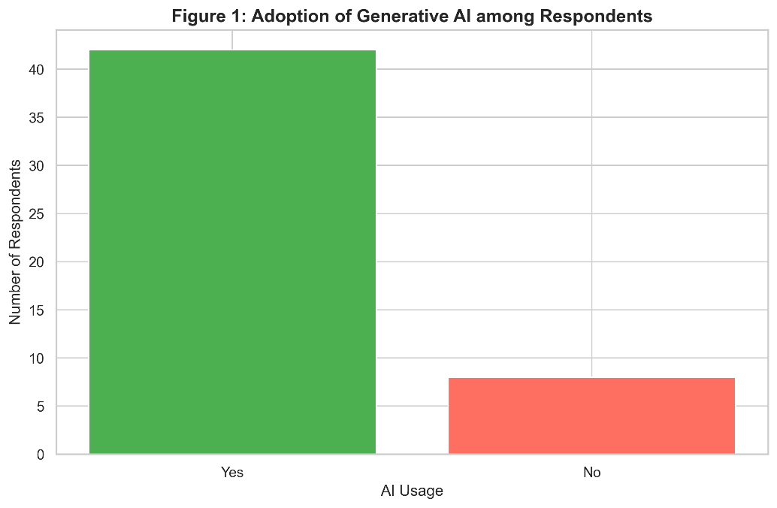
Figure 2. Adoption of Generative AI among respondents
Note: Most respondents reported using AI daily or several times per week, indicating strong integration of these tools into routine workflows.
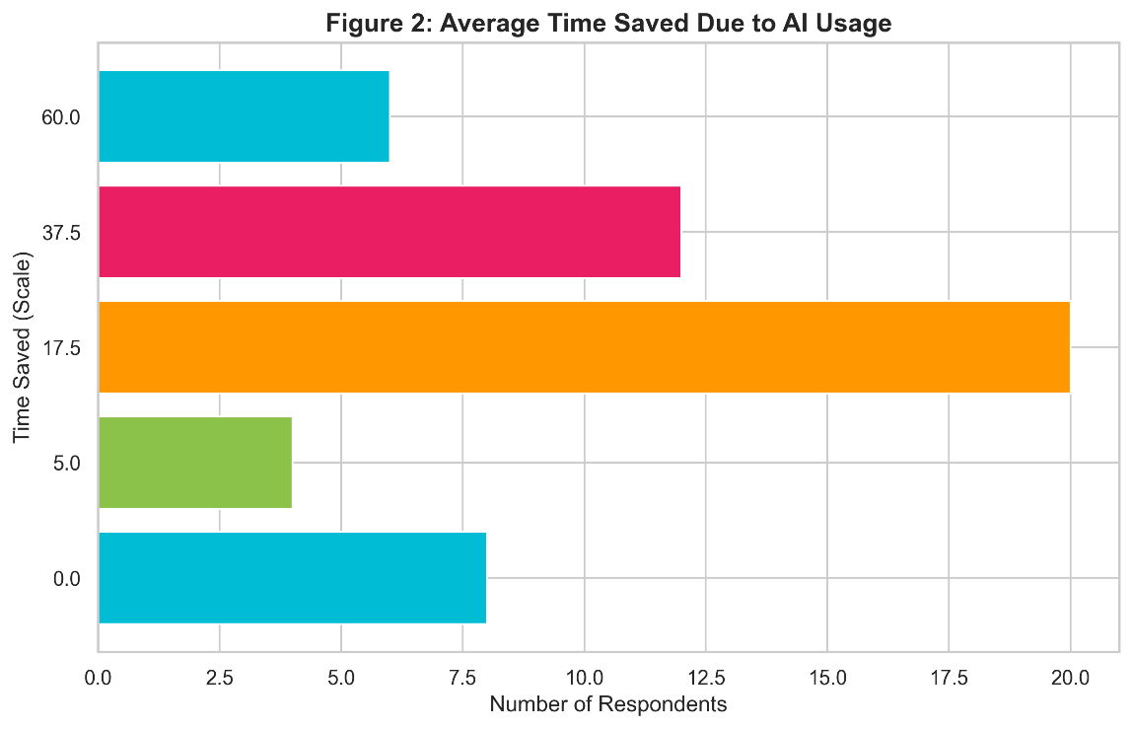
Figure 3. Average time saved due to AI usage
Note: Task completion times decreased significantly after AI adoption, especially for documentation, content generation, and repetitive tasks.

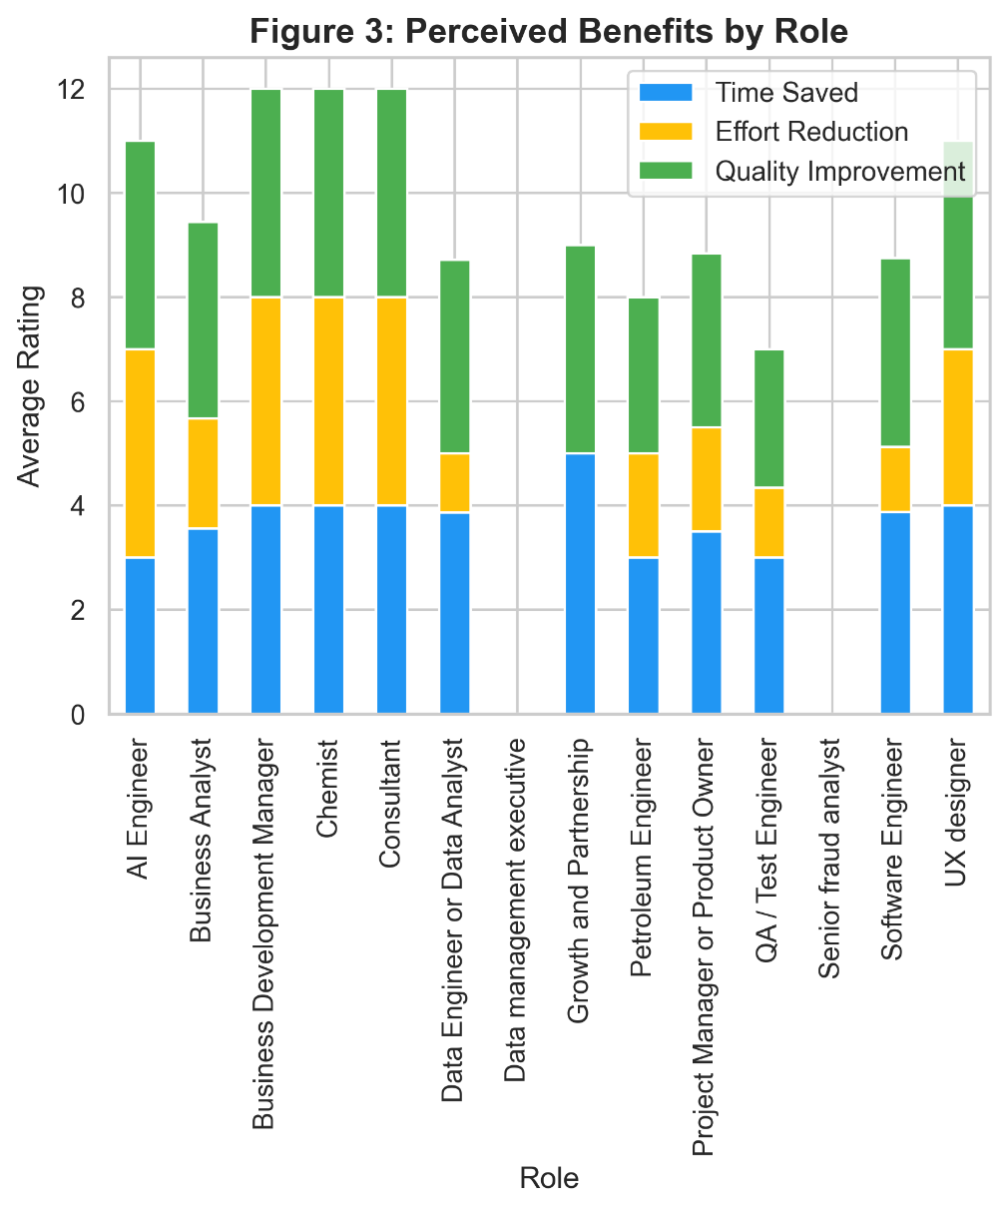
Figure 4. Frequency of Generative AI usage
Note: Consultants and software engineers reported the highest time savings, while business analysts emphasized quality improvements and reduced effort.
Together, these findings confirm that Generative AI adoption is associated with measurable improvements in productivity and perceived organizational advantage, warranting further statistical testing in subsequent sections.

Descriptive Statistics
The descriptive analysis was conducted in two stages: individual-level productivity assessment and project-level organizational outcomes. This dual approach ensured that the impact of Generative AI adoption was captured both at the micro (employee) and macro (project) scales.

4.3.1 Individual-Level Analysis
1. Productivity Calculator and AI Productivity Index (API) Construction
To quantify the impact of Generative AI on individual performance, a Productivity Calculator was developed and applied to the dataset. The model incorporates key input variables including AI usage frequency, percentage of tasks assisted by AI, and time taken to complete tasks before and after AI adoption.
A derived metric, time saved per task, was calculated as the difference between pre-AI and post-AI task completion time. This was further used to compute the productivity gain percentage, defined as the proportional reduction in task completion time after AI adoption.
In addition, perceived productivity improvements—captured through Likert-scale responses on productivity volume, effort reduction, rework reduction, and quality improvement—were normalized to a 0–100 scale. These responses were aggregated to form a composite perceived benefit score, representing subjective productivity enhancement.
The above components were combined using a weighted linear model to construct the AI Productivity Index (API).
AI Productivity Index (API): Composite Index Formulation
The AI Productivity Index (API) is a composite index based on a weighted linear model, designed to convert multiple productivity-related variables into a single standardized score on a 0–100 scale.
Meaning of Composite Index
A composite index is a statistical technique used to combine multiple indicators into a single measure. In this study, it allows the transformation of heterogeneous productivity dimensions into one unified score representing overall AI-driven productivity.
API Formula
$$API=w_{1}X_{1}+w_{2}X_{2}+w_{3}X_{3}+w_{4}X_{4}$$
Where:
X₁ = Frequency of AI usage
X₂ = Percentage of tasks assisted by AI
X₃ = Productivity gain (%)
X₄ = Perceived benefits score (0–100 scale)
And:
w₁ = 0.3 (Frequency of AI usage)
w₂ = 0.2 (% Tasks assisted)
w₃ = 0.3 (Productivity gain)
w₄ = 0.2 (Perceived benefits)

Weightage Justification
The weights were assigned using expert judgment based on the relative importance of each construct in influencing employee productivity. Productivity gain and AI usage frequency were assigned higher weights (0.3 each) as they directly reflect output improvement and adoption intensity. Task assistance and perceived benefits were assigned moderate weights (0.2 each) as they represent usage breadth and subjective validation of AI impact.
Implementation
The Productivity Calculator was applied row-wise across all observations in the dataset. The computed outputs—time saved per task, productivity gain percentage, and AI Productivity Index—were then merged back into the dataset. This enriched dataset was subsequently used for descriptive statistics, hypothesis testing, and inferential analysis to evaluate the impact of Generative AI on employee productivity.
2. Statistical Validation of AI Impact on Productivity
To statistically validate the impact of Generative AI on employee productivity, both comparative and predictive statistical analyses were conducted. These tests were designed to establish not only whether AI improves productivity, but also the strength and drivers of this improvement.
1. Paired t-test (Before vs After AI Adoption)
First, a paired t-test was applied to compare task completion time before and after AI adoption for the same individuals. This test is appropriate because it evaluates changes within the same subjects, thereby isolating the effect of AI usage.
The results indicated a statistically significant reduction in task completion time:
- t = 7.98
- p < 0.001
This confirms that employees’ complete tasks significantly faster after adopting AI tools. In other words, AI usage leads to measurable and meaningful efficiency gains at the individual level.
2. Independent t-test (AI Users vs non-users)
Next, an independent sample t-test (Welch’s variant) was conducted to compare productivity gains between AI users and non-users. This test helps determine whether productivity differences exist between two distinct groups.
The results showed a highly significant difference:
- t = 14.56
- p < 0.001
The one-tailed test further strengthened the hypothesis by confirming that AI users exhibit significantly higher productivity gains compared to non-users. This provides strong evidence that AI adoption is associated with improved performance outcomes.
3. Linear Regression Analysis (Drivers of Productivity)
Finally, a linear regression model was developed to examine how AI usage intensity influences productivity gains. This analysis goes beyond comparison and focuses on prediction and explanation.
The model demonstrated strong explanatory power:
- R² = 0.604
This indicates that approximately 60.4% of the variation in productivity gains is explained by AI usage variables.
Furthermore, both key predictors were statistically significant:
- AI usage frequency (p < 0.01)
- Percentage of tasks assisted by AI (p < 0.01)
These results confirm that not only does AI adoption improve productivity, but higher levels of AI engagement (frequency and depth of use) further amplify productivity gains.
4. ANOVA Analysis of Role and Industry Differences
To complement the regression and t-test analyses, one-way ANOVA tests were conducted to examine whether the impact of Generative AI on productivity varied across employee roles or industries. The rationale for this analysis was to determine if certain functions (e.g., Business Analysts, Consultants, Project Managers) or sectors (e.g., IT Services, Consulting, Manufacturing) experienced disproportionately higher productivity gains, which would suggest role- or industry-specific adoption advantages.
The role-based ANOVA yielded F (13,36) = 0.82, p = 0.64, while the industry-based ANOVA produced F (10,39) = 1.12, p = 0.37. Both results were non-significant, indicating that differences in AI Productivity Index across roles and industries were not statistically meaningful. In practical terms, this means that productivity improvements from Generative AI adoption are broadly consistent across diverse functions and sectors.
Overall Interpretation
Collectively, these statistical findings provide robust empirical evidence that:
- AI adoption significantly improves employee productivity (confirmed by paired and independent t-tests)
- AI users outperform non-users in productivity outcomes
- The intensity of AI usage is a strong predictor of productivity improvement (validated through regression analysis)
Thus, the results strongly support the alternative hypothesis that Generative AI usage has a significant positive impact on employee productivity, both in terms of efficiency gains and usage intensity effects.
Although the ANOVA results did not reveal significant variation, this finding is valuable. It demonstrates that the productivity benefits of Generative AI are not confined to specific roles or industries but instead represent a universal effect. This supports the generalizability of AI adoption strategies and strengthens the case for enterprise-wide implementation, as organizations can expect similar productivity gains across different functions and domains.
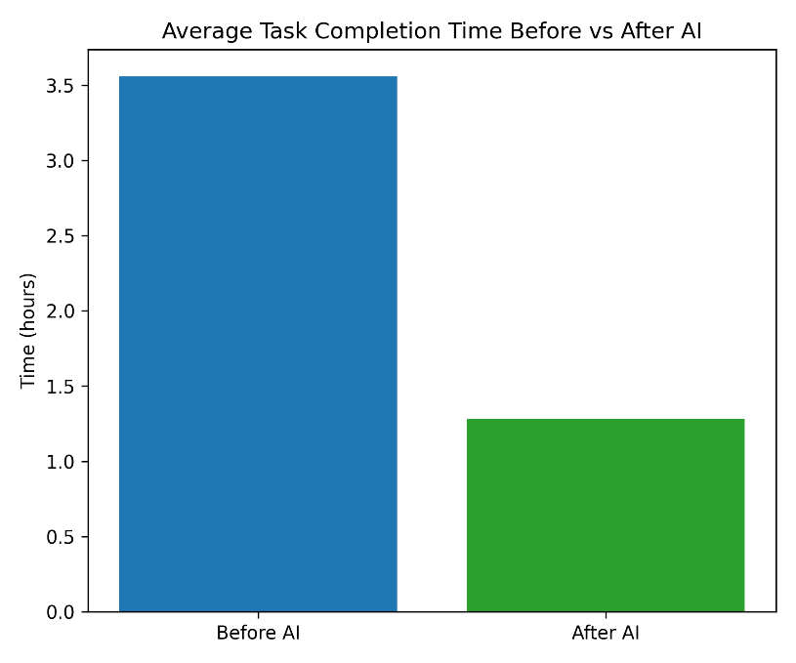
Figure 5. Average Task Completion Time Before vs. After AI
Note: This chart compares mean task completion times, showing clear reductions after AI adoption.
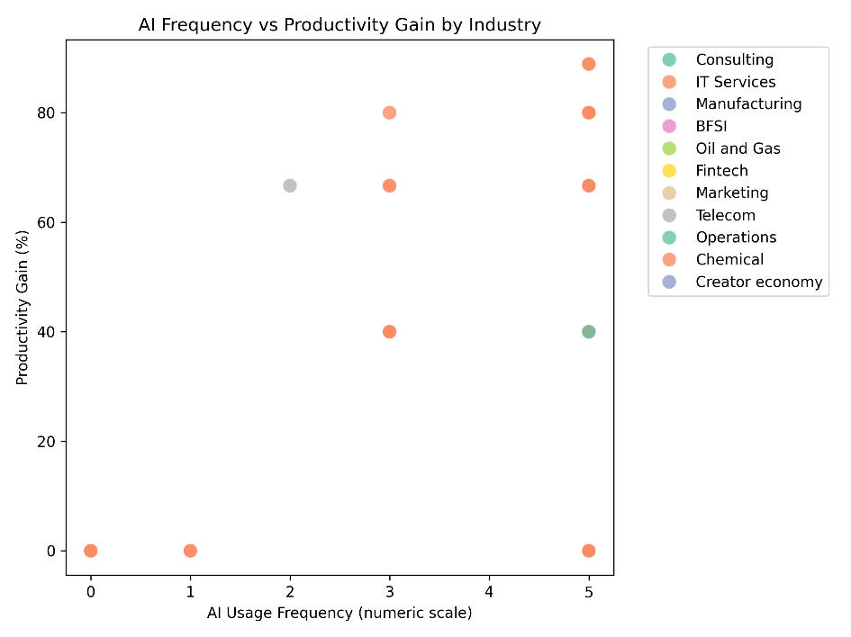
Figure 6. AI Frequency vs. Productivity Gain by Industry
Note: The scatter plot illustrates a positive relationship between AI usage frequency and productivity gain, differentiated by industry.
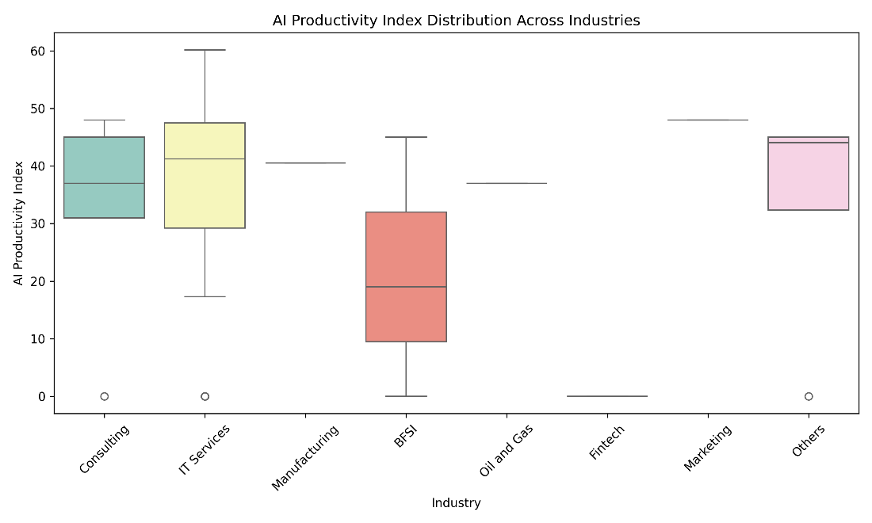
Figure 7. AI Productivity Index Distribution Across Industries
Note: The boxplot shows that productivity gains are broadly consistent across the top seven industries

4.3.2 Project-Level Regression Analysis
To examine whether individual productivity improvements scaled up to project, project-level outcomes were examined to assess whether productivity gains scale to organizational benefits.
1. Regression Results
Regression models were estimated with project-level outcomes (faster delivery, cost reduction, team efficiency, and competitive advantage) as dependent variables, and time saved per task, AI usage frequency, and AI-assisted task share as predictors.
- Faster Project Delivery: The model explained 12.8% of the variance (R² = 0.128). Time saved per task was significant (β = 0.017, p = 0.013), confirming that individual efficiency gains contribute to faster project delivery. AI frequency and task share were not significant.
- Cost Reduction: The model explained 8.3% of the variance (R² = 0.083). Time saved per task was marginally significant (β = 0.021, p = 0.050), suggesting efficiency gains reduce project costs.
- Team Efficiency: The model explained 5.9% of the variance (R² = 0.059). None of the predictors were significant, though time saved showed a positive trend (β = 0.0138, p = 0.107).
- Competitive Advantage: The model explained 7.8% of the variance (R² = 0.078). Time saved approached significance (β = 0.0144, p = 0.063), indicating partial linkage between individual efficiency and perceived competitive advantage.
Across models, time saved per task consistently emerged as the strongest predictor, reinforcing its role as the primary driver of project-level benefits.

Regression Results for Project-Level Outcomes

Dependent Variable | R² | Significant Predictor(s) | Coefficient (β) | p-value
Faster Delivery | 0.128 | Time Saved | 0.017 | 0.013
Cost Reduction | 0.083 | Time Saved | 0.021 | 0.050
Team Efficiency | 0.059 | None | – | –
Competitive Advantage | 0.078 | Time Saved (marginal) | 0.014 | 0.063

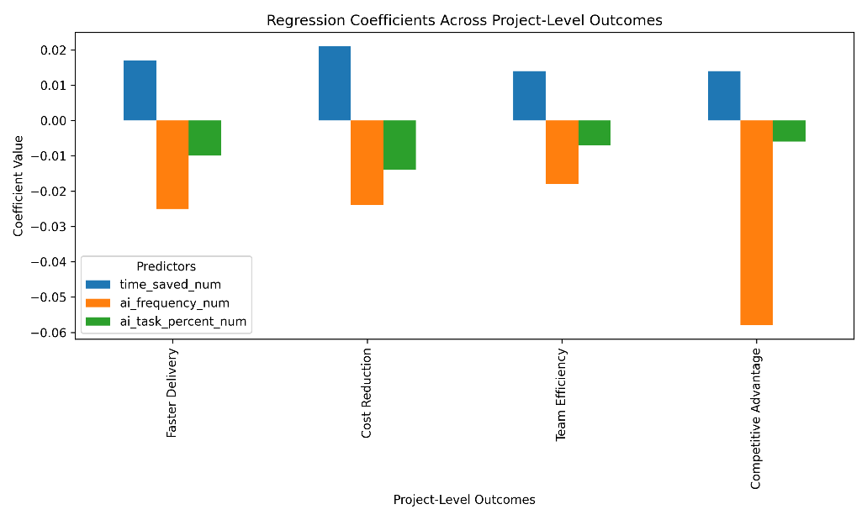
Figure 7. Regression coefficients across project-level outcomes.
Note: Time saved per task consistently shows the strongest positive effect, while AI frequency and task share are not significant predictors.
2. Factor Analysis
Exploratory factor analysis was conducted on the four project-level outcomes. All variables loaded strongly onto a single factor (loadings between –0.72 and –0.93), with 68.2% of variance explained. This validates the existence of a unified construct, termed AI-driven project efficiency, encompassing faster delivery, cost reduction, efficiency, and competitive advantage.
Factor Analysis of Project-Level Outcomes
Variable | Factor Loading
Faster Delivery | –0.72
Cost Reduction | –0.85
Team Efficiency | –0.93
Competitive Advantage | –0.79

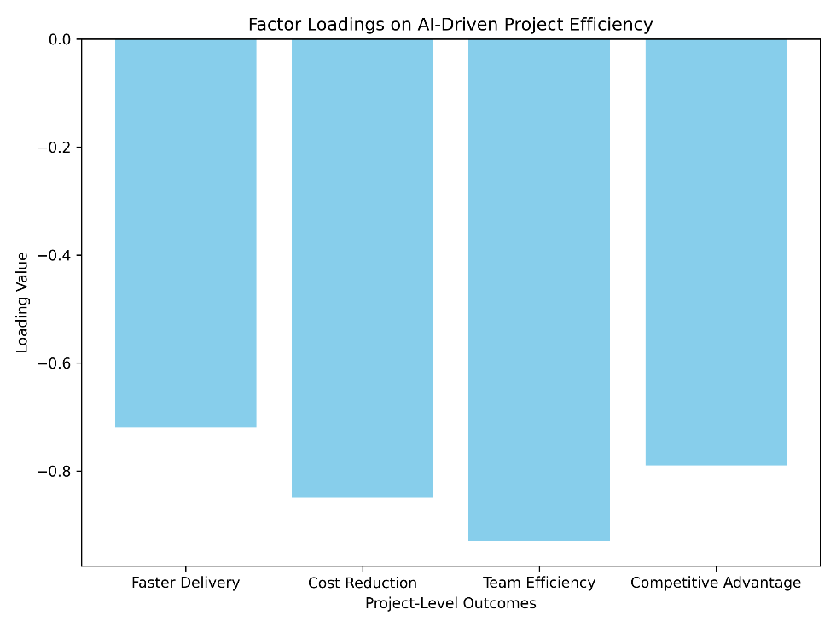
Figure 8. Factor loadings for project-level outcomes.
Note: All four outcomes load strongly onto a single latent construct, supporting the concept of “AI-driven project efficiency.
3. Chi-Square Tests
Regression and factor analysis confirm that individual productivity gains scale up to project-level efficiency, with time saved per task as the key driver. Factor analysis consolidates multiple outcomes into a single construct, while chi-square tests highlight cost reduction as the most consistently associated benefit. Together, these findings demonstrate that Generative AI adoption enhances project efficiency and contributes to organizational advantage, though the strength of effects varies across outcomes.
Chi-Square Tests: AI Usage vs Project Outcomes
Outcome | χ² Statistic | p-value | Association
Faster Delivery | 0.00 | 1.000 | Not significant
Cost Reduction | 4.11 | 0.043 | Significant
Team Efficiency | 1.67 | 0.435 | Not significant
Competitive Advantage | 0.88 | 0.643 | Not significant

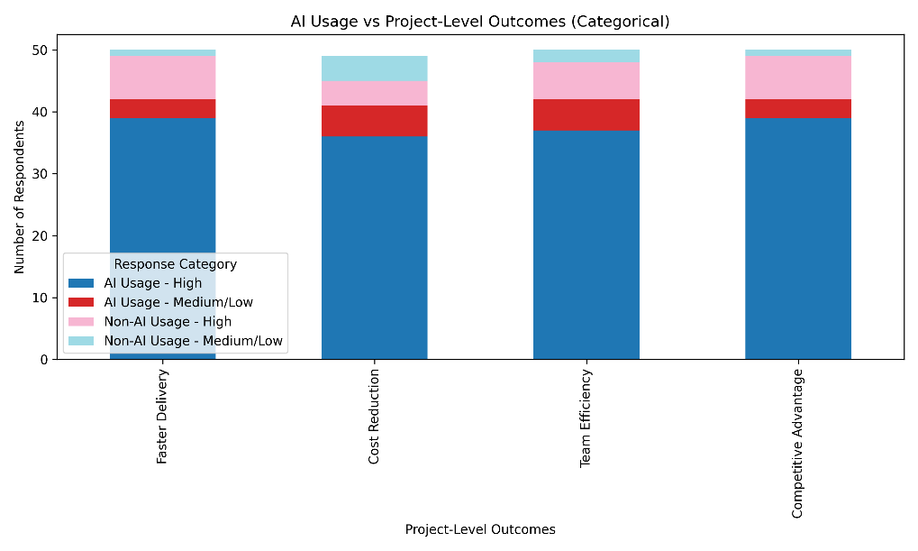

Figure 9. AI usage versus project-level outcomes (categorical)
Note: Chi-square analysis indicates a significant association between AI usage and cost reduction, but not with other outcomes.
Regression and factor analysis confirm that individual productivity gains scale up to project-level efficiency, with time saved per task as the key driver. Factor analysis consolidates multiple outcomes into a single construct, while chi-square tests highlight cost reduction as the most consistently associated benefit. Together, these findings demonstrate that Generative AI adoption enhances project efficiency and contributes to organizational advantage, though the strength of effects varies across outcomes.

4.3.3 ROI and Financial Impact
The financial analysis in the dashboard was derived by linking salary benchmarks with productivity gains observed in the survey data. Each role was assigned a standard salary range, which was converted into hourly, daily, monthly, and annual equivalents. These values formed the baseline for calculating savings from time reductions achieved through Generative AI adoption.
Step 1: Cost Conversion
Annual salaries were normalized into hourly rates using the formula:
$$\text{Hourly Cost}=\frac{\text{Annual Salary}}{220×8}$$
This was then extended to daily, weekly, monthly, and annual costs to provide a consistent framework for measuring savings.
Step 2: Productivity Savings
Time saved per task (from survey responses) was multiplied by the hourly cost to estimate daily savings. These were scaled up to weekly, monthly, and annual savings using standard working assumptions

The following formulas were applied:
- Hourly cost = Annual Salary ÷ (220 working days × 8 hours)
- Daily cost saved = Time saved × Hourly cost
- Weekly cost saved = Daily cost saved × 5 working days
- Monthly cost saved = Weekly cost saved × 4 weeks
- Annual saving = Monthly cost saved × 12 months

This conversion enabled direct linkage between time saved (from survey data) and financial savings (based on salary benchmarks).
Role | 0–2 yrs (₹ LPA) | 3–5 yrs (₹ LPA) | 6–10 yrs (₹ LPA) | 10+ yrs (₹ LPA) | Approx. Hourly Cost Range* | Midpoint (₹/hour)
Business Analyst | 4–6 | 8–12 | 15–20 | 25–35 | ₹225–₹1,990/hour | 1,107.5
Data Engineer / Data Analyst | 5–7 | 10–15 | 18–25 | 30–40 | ₹280–₹2,270/hour | 1,275
Software Engineer | 4–6 | 9–14 | 18–28 | 30–45 | ₹225–₹2,560/hour | 1,392.5
QA / Test Engineer | 3–5 | 7–10 | 12–18 | 20–28 | ₹170–₹1,590/hour | 880
Project Manager / Product Owner | 6–9 | 12–18 | 20–28 | 30–50 | ₹340–₹2,840/hour | 1,590
Other (custom role) | 3–6 | 8–12 | 15–22 | 25–40 | ₹170–₹2,270/hour | 1,220

Step 3: AI Cost Adjustment
A standard AI cost was assumed for all employees, representing the average annual licensing and enablement expense.
- Monthly AI Cost: ₹1,650
- Annual AI Cost: ₹19,800

Net savings were calculated by deducting this cost from gross annual savings:
$$\text{Net Annual Saving}=\text{Annual Saving}-\text{Annual AI Cost}$$
This ensures that productivity gains are measured against both employee cost savings and AI investment.
Step 4: ROI Calculation
Return on Investment (ROI) was measured as the ratio of net annual savings to AI cost:
$$\text{ROI}=\frac{\text{Net Annual Saving}}{\text{Annual AI Cost}}$$
This metric demonstrates the efficiency of AI adoption by showing how much benefit is realized for every unit of cost incurred.
Dashboard Outputs
The executive dashboard summarized these calculations as follows:
- Total Employee Cost: ₹87.5M
- Annual Saving: ₹28.39M
- Annual AI Cost: ₹0.83M
- Net Annual Saving: ₹27.56M
- ROI: 3314%
These results confirm that Generative AI adoption yields substantial productivity and cost benefits, even after accounting for technology expenses.

Dashboard Details and Data Source
The dashboards were developed in Power BI using an Excel file that contained three sheets: Assessment Responses, Productivity Gain, and Python Output. For visualization purposes, individual job roles were grouped into a defined list (Software Engineer, Business Analyst, Data Engineer, Project Manager, QA/Test Engineer), while all other positions were consolidated under the category “Others.” This structured integration ensured consistency in analysis and allowed the dashboards to present a comprehensive view of financial savings, productivity improvements, and role-wise adoption patterns.
Sheet 1: Assessment Responses
- Contains all raw survey responses collected from employees.
- Includes variables such as role, years of experience, AI usage frequency, tools used, task completion time before and after AI, and perceived productivity benefits.
- Serves as the primary dataset for role-wise adoption and perception analysis.

Sheet 2: Productivity Gain
- Holds calculations related to cost savings and efficiency improvements.
- Converts annual salaries into hourly, daily, weekly, monthly, and annual equivalents.
- Links time saved (from survey data) with financial savings to derive metrics such as daily saving, weekly saving, monthly saving, annual saving, and ROI.
- Provides the financial backbone of the dashboard.

Sheet 3: Python Output
- Contains processed results generated from Python scripts.
- Includes statistical outputs, regression analysis, and productivity index calculations.
- Used to validate survey findings and enrich the dashboard with analytical insights.

- Executive level Dashboard
This dashboard summarizes the overall organizational benefits of AI adoption. It highlights total employee cost, annual savings, AI enablement cost, net annual savings, and ROI. In addition, it visualizes time efficiency metrics, average time saved, and productivity index factors such as team efficiency, rework reduction, quality improvement, and faster delivery. Adoption frequency by role is also included, demonstrating how AI integration contributes to measurable cost reduction and enhanced operational efficiency at the executive level.
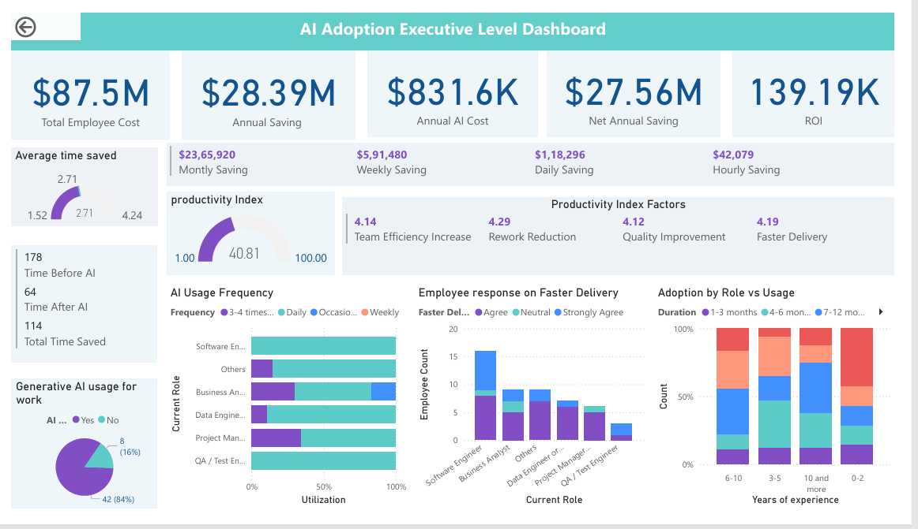
Figure 10. AI Adoption Executive‑Level Dashboard
Note: Consolidated view of financial and productivity impact of Generative AI adoption.

- Role wise details Dashboard
This dashboard provides a detailed breakdown of salary benchmarks and productivity savings across different job roles. It shows annual, monthly, weekly, and daily savings derived from standardized salary conversions and time-efficiency data. The accompanying chart compares productivity index, faster delivery, time saved, cost reduction, and quality improvement by role. The visualization demonstrates that technical roles such as Software Engineers and Data Engineers generate the highest savings, while QA/Test Engineers record the lowest, highlighting the differentiated impact of Generative AI adoption across the workforce.
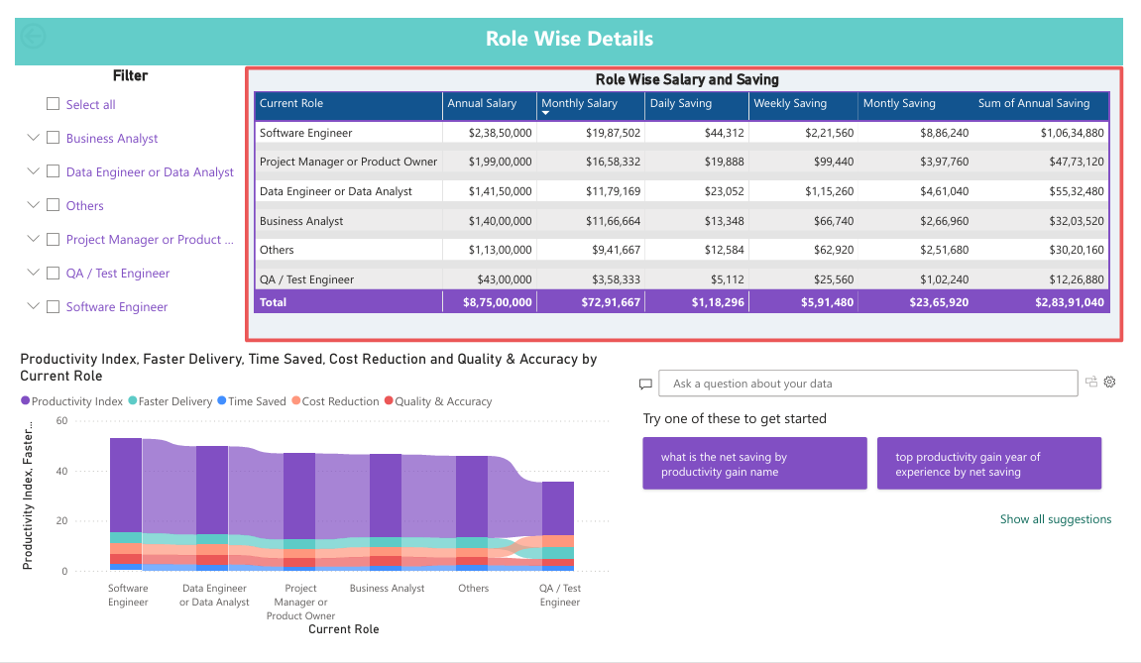
Figure 11. AI Adoption Executive‑Level Dashboard
Note: Role‑wise comparison of salary structures and savings achieved through AI adoption.
- Role-Wise Response Dashboard
This dashboard illustrates how employees across different roles perceive the impact of Generative AI on organizational performance. The donut charts show that most respondents agree or strongly agree that AI strengthens competitive advantage and is viewed more as a supportive tool than a risk. The bar chart highlights role-wise differences in resource utilization, reduction of manual effort, and rework reduction, with technical roles such as Software Engineers and Data Engineers reporting higher efficiency gains. The role-specific task mapping further indicates that Business Analysts primarily use AI for documentation, while engineers leverage it for coding and development, and managers apply it for data analysis and reporting. Together, these insights emphasize the varied but positive influence of AI adoption across professional functions.
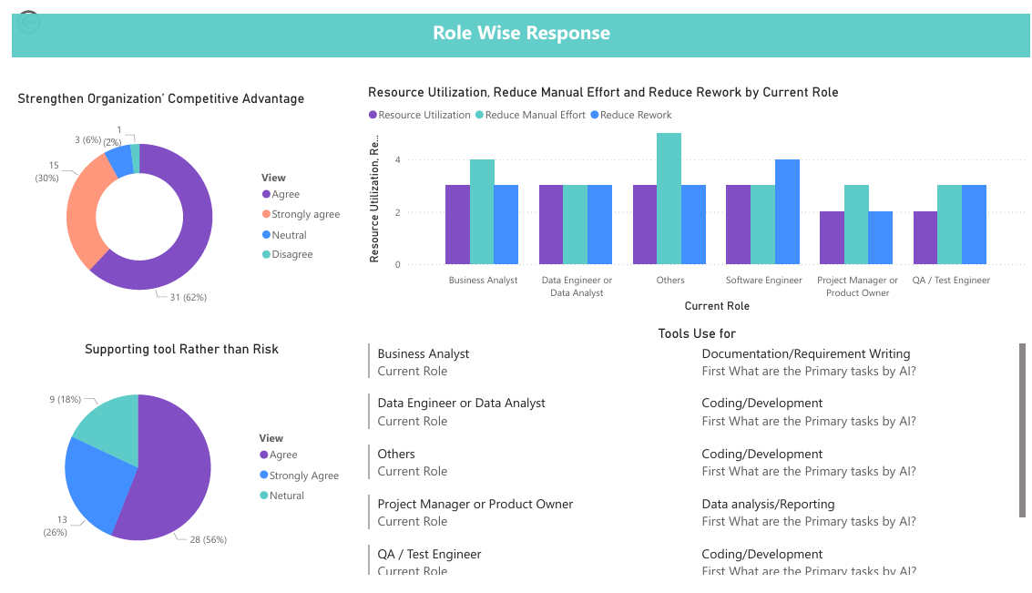
Figure 12. Role-Wise Response Dashboard
Note: Survey responses on AI adoption perceptions and role-specific usage patterns.

Chapter 5: Conclusion
This study set out to evaluate the impact of Generative AI adoption on employee productivity, efficiency, and organizational outcomes within IT services. By integrating survey responses, cost benchmarking, and statistical analysis, the project has successfully demonstrated how AI usage translates into measurable financial savings and competitive advantage.
The research addressed faculty feedback by refining the methodology to include both objective and perception-based measures of productivity. Task completion times before and after AI adoption provided quantifiable evidence of efficiency gains, while Likert-scale responses captured employee perceptions of improvement. The segmentation of AI users versus non-users enabled comparative analysis, highlighting variability in returns and validating the hypothesis that AI adoption leads to significant productivity gains. Sub-hypotheses at the task level further clarified role-specific differences, showing that technical roles such as Software Engineers and Data Engineers achieved the highest savings, while QA/Test Engineers reported more modest improvements.
The integration of business-level outcomes—faster delivery timelines, improved work quality, and enhanced decision-making—established a clear linkage between micro-level productivity improvements and organizational competitive advantage. Dashboards developed in Power BI, using structured inputs from Excel and Python outputs, provided an executive-level view of savings, ROI, and adoption patterns. These visualizations not only validated the analytical findings but also offered actionable insights for managerial and strategic decision-making.
Overall, the project demonstrates that Generative AI adoption delivers substantial productivity and cost benefits, even after accounting for enablement expenses. The findings contribute to both academic research and practical business applications by offering a structured framework to measure AI’s impact, analyze variability in returns, and support data-driven decision-making.

5.1 Recommendations and Future Scope
- Scaling AI Adoption: Organizations should encourage wider adoption of Generative AI tools across roles, especially in functions where measurable productivity gains have already been demonstrated.
- Task-Specific AI Tools: Future research can explore specialized AI applications tailored to tasks (e.g., documentation, coding, testing) to maximize efficiency.
- Longitudinal Studies: Conducting long-term studies will help assess sustained productivity improvements and ROI over multiple years, beyond initial adoption phases.
- Cross-Industry Comparison: Extending the study to other industries (finance, healthcare, manufacturing) can provide insights into sector-specific adoption patterns and benefits.
- Integration with Business Analytics: Combining AI productivity metrics with broader business analytics frameworks can enhance strategic decision-making and resource allocation.
- Employee Training and Change Management: To maximize ROI, organizations should invest in training programs and change management initiatives that build employee confidence in AI tools.

5.2 Closing Statement
In conclusion, this project demonstrates that Generative AI adoption is not only a technological advancement but also a strategic enabler of productivity, efficiency, and competitive advantage. By combining survey insights, statistical validation, and executive-level dashboards, the study provides a practical framework for organizations to measure and maximize the returns from AI integration. The findings reinforce that data-driven approaches to AI adoption can transform operational performance and support informed managerial decision-making, paving the way for sustainable business growth in the digital era.

5.3 Future Research Directions
- Longitudinal Impact Studies: Future research can track productivity gains and ROI over multiple years to assess the sustainability of AI adoption beyond initial implementation.
- Task-Level Deep Dive: Expanding analysis to specific task categories (e.g., documentation, coding, testing, reporting) will help identify where AI delivers the greatest efficiency improvements.
- Cross-Industry Comparisons: Applying the same framework in different sectors such as finance, healthcare, and manufacturing can reveal industry-specific adoption patterns and benefits.
- Integration with Broader Analytics: Linking AI productivity metrics with enterprise-wide analytics systems can strengthen strategic decision-making and resource allocation.
- Human Factors and Change Management: Exploring employee attitudes, training effectiveness, and organizational readiness will provide insights into maximizing adoption success.

Risks and Mitigation Plan
Like any research study, this project is subject to certain risks that may impact the quality, reliability, and timeliness of outcomes. Identifying these risks in advance and outlining appropriate mitigation strategies is essential to ensure the smooth execution of the study.
The key risks associated with this project and their corresponding mitigation measures are presented below:
Risk | Mitigation
Delay in Survey responses and Low survey response rate | Expand survey distribution through LinkedIn, peer groups, and professional communities; follow up with respondents to improve participation
Self-reported bias in responses | Design structured and objective questions to minimize subjectivity and ensure consistency
Data inconsistency and incomplete responses | Will perform thorough data validation and cleaning before analysis to ensure accuracy and reliability
Time constraints in project completion | Adhere to a well-defined research timeline and monitor progress regularly to ensure timely completion

By proactively addressing these risks, the study aims to maintain methodological rigour and ensure the validity of its findings.

Expected Benefits
The successful completion of this study is expected to generate both academic and practical benefits, contributing to a deeper understanding of the role of Generative AI in enhancing productivity and driving competitive advantage.
The key expected benefits of the study are as follows:
- Quantitative measurement of productivity improvements: The study will provide a structured and data-driven assessment of how Generative AI impacts employee productivity across multiple dimensions, including time efficiency, work efficiency, and output quality.

- Comparative analysis of work methodologies: It will enable a clear comparison between traditional workflows and AI-assisted processes, highlighting the extent of efficiency gains achieved through AI adoption.

- Insights into competitive advantage: The study will explore how productivity improvements translate into broader organizational benefits, such as improved delivery timelines, better decision-making, and enhanced competitive positioning.

- Practical implications for managerial decision-making: By integrating business analytics techniques, the study will demonstrate how data-driven insights can support strategic and operational decision-making within organizations.

- Academic contribution to existing literature: The research will contribute to the academic domain by addressing gaps related to the measurement of AI-driven productivity and by integrating concepts from business analytics, Generative AI, and performance evaluation.
Overall, the study aims to bridge the gap between theoretical understanding and practical application, providing actionable insights for both researchers and industry practitioners.

Annexures

Annexure A: Survey Questionnaires
This annexure presents the survey questionnaire used for primary data collection in the study. The questionnaire was designed to capture information related to Generative AI usage, productivity improvements, output quality, and business impact.

Section 1: Respondent Profile

- Email *

- Name *

- Gender * (Select one)
- Male
- Female
- Prefer not to say
- Other

- Organization Name *

- Current Role * (Select one)
- Business Analyst
- Data Engineer or Data Analyst
- Software Engineer
- QA / Test Engineer
- Project Manager or Product Owner
- Other: _______

- Years of Experience * (Select one)
- 0-2
- 3-5
- 6-10
- 10+

- Industry/Domain * (Select one)
- IT services
- Consulting
- BFSI
- Healthcare
- Retail
- Others

- Do you use Generative AI for your office work? * (Select one)
- Yes
- No

Section 2: AI Usage Details

- Which AI tools do you use? * (Mark multiple)
- ChatGPT
- GitHub Copilot
- Microsoft Copilot
- Gemini
- Other

- How long have you been using Generative AI at work? * (Select one)
- 1–3 months
- 4–6 months
- 7–12 months
- 12+ months

- Frequency of AI usage at Work * (Select one)
- Daily
- 3–4 times/week
- Weekly
- Occasionally

- What are the Primary tasks for which you use Generative AI? * (Mark multiple)
- Coding / Development
- Documentation / Requirement Writing
- Testing / Debugging
- Data analysis/reporting
- Email, Research / Knowledge Search
- Other

- Approximately what percentage of your tasks involve AI assistance? * (Select one)
- 0–10%
- 10–25%
- 25–50%
- More than 50%

- Average time to complete a standard task BEFORE AI * (Select one)

- Less than 2 hours
- 2–4 hours
- 4–6 hours
- More than 8 hours

- Average time to complete the same task AFTER AI * (Select one)
- Less than 2 hours
- 2–4 hours
- 4–6 hours
- More than 8 hours

- Estimated % time saved due to AI * (Select one)
- 0–10%
- 10–25%
- 25–50%
- More than 50%
- AI enablement helps to complete a higher volume of tasks within the same time frame. * (Select one)
- Strongly Agree
- Agree
- Neutral
- Disagree
- Strongly Disagree

- AI reduces your manual effort and repetitive work in my daily tasks. * (Select one)
- Strongly Agree
- Agree
- Neutral
- Disagree
- Strongly Disagree

- AI helps you to identify errors and resolve faster to reduce rework. * (Select one)
- Strongly Agree
- Agree
- Neutral
- Disagree
- Strongly Disagree

- AI improves the quality and accuracy of my deliverables. * (Select one)
- Strongly Agree
- Agree
- Neutral
- Disagree
- Strongly Disagree

- AI-driven productivity improvements contribute to faster project delivery. * (Select one)
- Strongly Agree
- Agree
- Neutral
- Disagree
- Strongly Disagree

- AI-driven productivity improvements help reduce project duration and cost. * (Select one)
- Strongly Agree
- Agree
- Neutral
- Disagree
- Strongly Disagree

- AI improves team efficiency and resource utilisation * (Select one)
- Strongly Agree
- Agree
- Neutral
- Disagree
- Strongly Disagree

- AI adoption strengthens the organization’s competitive advantage. * (Select one)
- Strongly Agree
- Agree
- Neutral
- Disagree
- Strongly Disagree

- Do you think AI acts as a supportive tool rather than a risk in work? * (Select one)
- Strongly Agree
- Agree
- Neutral
- Disagree
- Strongly Disagree

Section 3: Non-AI Usage Details

- What is the primary reason for not using Generative AI tools? * (Check all that apply.)
- Company policy restrictions
- Data security or confidentiality concerns
- Lack of training or awareness
- Not required for my role
- Concerns about accuracy/reliability
- Other

- Do you believe Generative AI could improve your productivity? *
- Strongly Agree
- Agree
- Neutral
- Disagree
- Strongly Disagree

- Do you think AI-driven productivity improvements contribute to faster project delivery? * (Select one)
- Strongly Agree
- Agree
- Neutral
- Disagree
- Strongly Disagree

- Do you think AI-driven productivity improvements help reduce project duration and cost? * (Select one)
- Strongly Agree
- Agree
- Neutral
- Disagree
- Strongly Disagree

- Do you think AI improves team efficiency and resource utilization? * (Select one)
- Strongly Agree
- Agree
- Neutral
- Disagree
- Strongly Disagree
- Do you think AI adoption strengthens the organization’s competitive advantage? * (Select one)
- Strongly Agree
- Agree
- Neutral
- Disagree
- Strongly Disagree
- Do you think AI acts as a supportive tool rather than a risk in work? * (Select one)
- Strongly Agree
- Agree
- Neutral
- Disagree
- Strongly Disagree

Annexure B: Survey Responses
Screenshot of responses received.
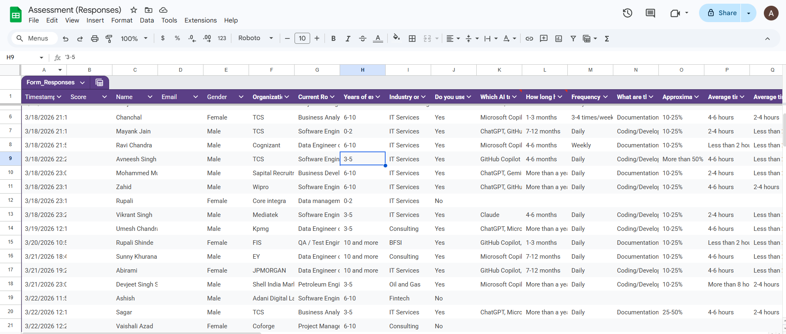

Annexure C: Python Code Screen shots
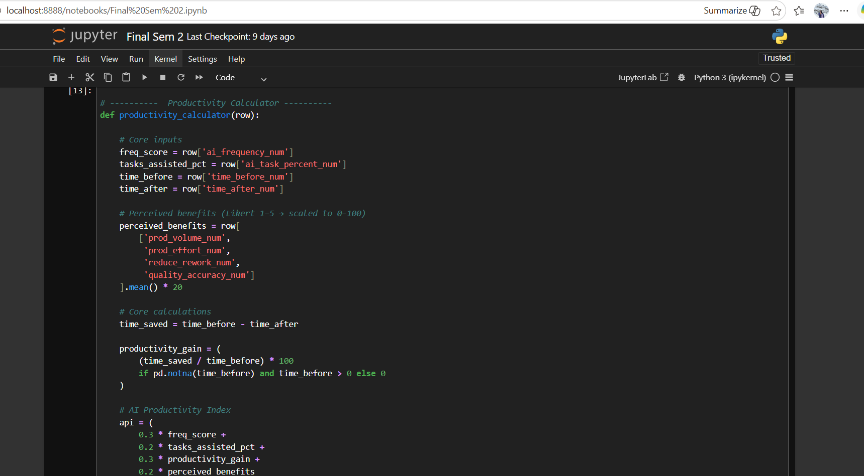
Figure 13: Productivity Index calculator.

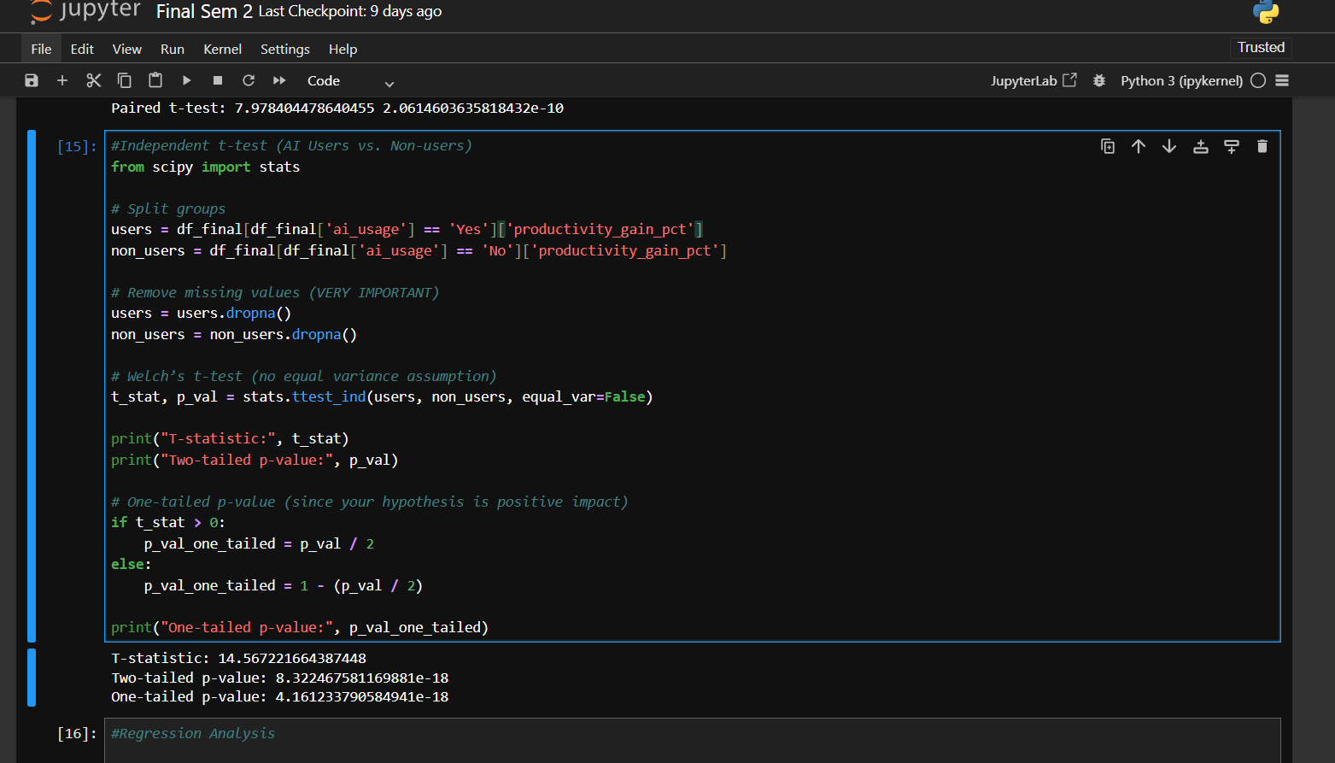
Figure 14: Test Performed
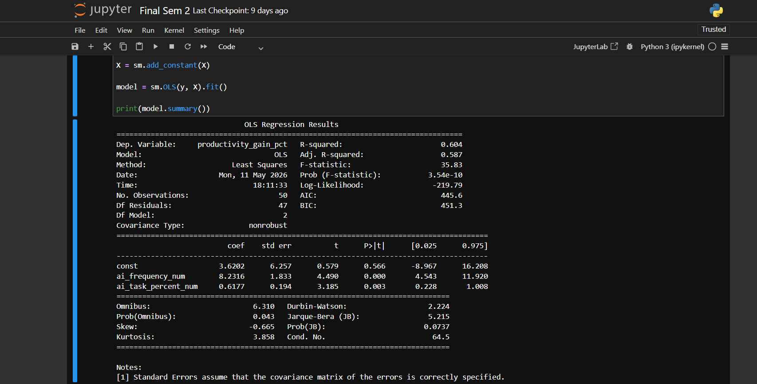
Figure 15: Regression Result

Annexure C: Link to Files

1. Excel File use for Python Analysis
2. Excel File use for Dashboard Analysis
3. Excel File use for Python Output Analysis
4. Python Analysis Notebook
5. Power BI Dashboard File

Glossary
Term | Definition
Generative AI | A type of Artificial Intelligence that generates content such as text, code, or data based on user inputs.
Artificial Intelligence (AI) | Technology that enables machines to simulate human intelligence such as learning and decision-making.
Productivity | A measure of efficiency, indicating output achieved per unit of time or effort.
Time Efficiency | Reduction in time required to complete tasks while maintaining quality.
Work Efficiency | Ability to achieve more output with less effort or resources.
Output Quality | Accuracy, consistency, and reliability of work results.
Competitive Advantage | The ability of an organization to outperform competitors through better efficiency or innovation.
AI Adoption | The extent to which AI tools are implemented and used in work processes.
Task Completion Time | The time taken to complete a specific task.
Secondary Data | Data collected from existing sources such as reports or research.
Regression Analysis | A statistical method used to analyze relationships between variables.
Likert Scale | A scale used in surveys to measure opinions (e.g., Strongly Agree to Strongly Disagree).
Data Cleaning | Process of removing errors or inconsistencies from data.
IT Services Industry | Sector providing IT-related services such as software development and consulting.
AI Productivity Index (API) | A composite measure (scaled 1–100) that combines frequency of AI usage, percentage of tasks assisted, productivity gain, and perceived benefits such as efficiency, error reduction, and quality improvement
Return on Investment (ROI) | A financial metric showing efficiency of AI adoption, calculated as the ratio of net annual savings to annual AI cost.

References
- Accenture. (2023). A new era of generative AI for everyone. Retrieved from https://www.accenture.com
- Bughin, J., Hazan, E., Ramaswamy, S., Chui, M., Allas, T., Dahlström, P., Henke, N., & Trench, M. (2018). Notes from the AI frontier: Insights from hundreds of use cases. McKinsey Global Institute.
- Erik Brynjolfsson, Li, D., & Raymond, L. R. (2023). Generative AI at work: Evidence from a field experiment (NBER Working Paper No. 31161). National Bureau of Economic Research.
- Thomas H. Davenport, & Rajeev Ronanki (2018). Artificial intelligence for the real world. Harvard Business Review, 96(1), 108–116.
- Fabrizio Dell’Acqua, McFowland, E., Mollick, E. R., Lifshitz-Assaf, H., Kellogg, K., Rajendran, S., & Malone, T. W. (2023). Navigating the jagged technological frontier: Outcomes of artificial intelligence on high-value knowledge work. Harvard Business School Working Paper.
- Gartner. (2023). Generative AI and industry adoption trends. Retrieved from https://www.gartner.com
- Andrew McAfee, & Erik Brynjolfsson (2017). Machine, platform, crowd: Harnessing our digital future. W. W. Norton & Company.
- McKinsey & Company. (2023). The economic potential of generative AI: The next productivity frontier. Retrieved from https://www.mckinsey.com
- Shakked Noy, & Whitney Zhang (2023). Experimental evidence on the productivity effects of generative artificial intelligence. Science, 381(6654), 187–192. https://doi.org/10.1126/science.adh2586
- Solow, R. M. (1987). We’d better watch out. New York Times Book Review, 36, 12.
- Scaler. (2026). IT salary overview in India 2026. Scaler. Retrieved May 3, 2026, from https://www.scaler.com/topics/it-salary-overview-in-india/
- Microsoft Copilot: Microsoft. (2026). Microsoft 365 Copilot plans. Retrieved from https://www.microsoft.com/en-us/microsoft-365/explore-microsoft-365-for-home
- GitHub Copilot: GitHub. (2026). GitHub Copilot pricing. Retrieved from https://github.com/features/copilot
- ChatGPT Plus: OpenAI. (2026). ChatGPT pricing. Retrieved from https://openai.com/chatgpt/pricing
- Claude Pro: Anthropic. (2026). Claude pricing. Retrieved from https://claude.ai/pricing
- Google Gemini: Google. (2026). Google Workspace pricing. Retrieved from https://workspace.google.com/pricing.html (workspace.google.com in Bing)

